# Executive summary

Australia’s fiscal position is similar to many OECD peers, but underlying pressures mean current settings are not sustainable in the long run. The challenge is not the prospect of an imminent debt crisis, but instead a question of efficiency and fairness. Specifically, whether Australia’s fiscal settings and institutions are delivering resilience, equity, and efficiency in the face of demographic change, weak productivity growth, and shifting economic risks.

One challenge is the limited focus on the underlying drivers of fiscal trends below the high-level aggregates that dominate public debate. This neglect is particularly stark on the spending side of the government’s budget, which is the primary focus of this report.

These trends and associated risks are especially apparent when the Federal and State budgets are **consolidated**. Over the past decade, consolidated net debt has exceeded its mid-1990s peaks and is projected to keep rising given demographic change and the inflexibility of fiscal institutions. This is largely reflected in an increase in consolidated government spending, which has risen by 3.5 percentage points of GDP over the past two decades. The main drivers of this growth are higher spending on health, social protection, and education – with a rise in both general expenditure and capital investment contributing equally.

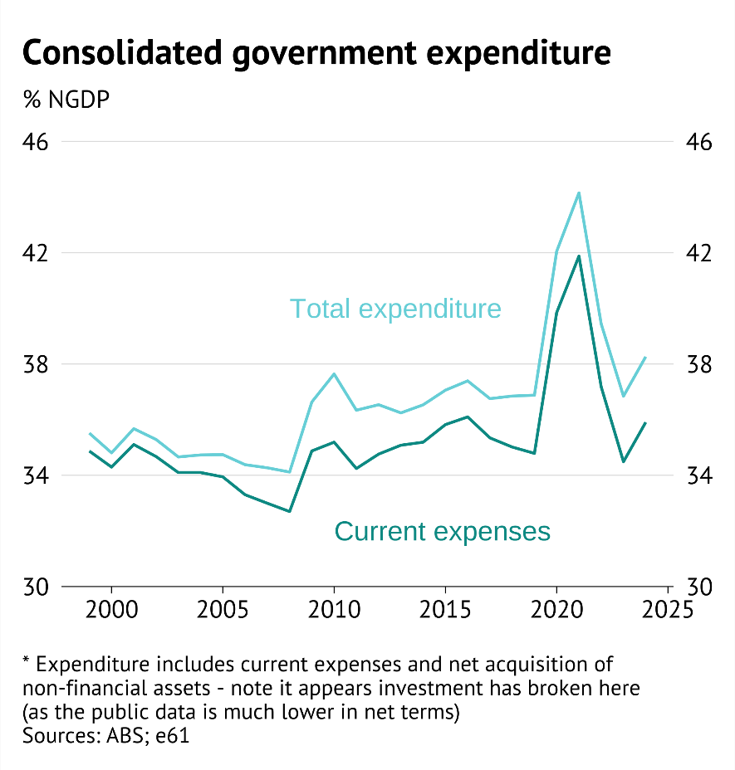

Figure

Many of these spending pressures are structural: an ageing population is increasing demand for health and aged care, while labour-intensive services, such as providing supports to people with disability and child care, face rising costs. At the same time, productivity growth has slowed, limiting revenue capacity. The tax system, while not a focus of this report, compounds the problem by relying on narrow and distortionary bases, such as stamp duty, that increase the cost of raising revenue.

However, consolidated government spending out of national income has grown faster than expected since the mid-2000s, even after adjusting for demographic change. This captures a broader trend of spending **convergence** between low spending and high spending OECD countries. However, benchmarking exercises highlight that Australia’s spending trajectory has further diverged from peers – with expenditure persistently elevated after the Global Financial Crisis.

Further analysis highlights that expenditure pressures in several government functions can help to explain these patterns.

* **Health**: Spending on health has been facing greater demographic pressures, and has evolved in line with those pressures. If this trend continues health spending will rise from 7.1% of GDP now to 10% by 2060.
* **Education**: Spending on education has been flat even as population ageing should have reduced spending pressures – current spending is 0.5% of GDP higher than demographic trends would have projected. This is because of a rapid increase in per student spending in primary and secondary education.
* **Social protection:** Spending in social protection has become increasingly less targeted with:
  + A reduction in family income support payments as a share of GDP (which is largely explained by demographic changes) while in-kind support like child care has surged.
  + A sharp increase in support for those with disability through in-kind support, through the NDIS, while disability income support payments have declined.
  + Although social protection spending is currently contained, the move to in-kind supports will keep expenditure at current levels even if the relative value of income support continues to decline – as demand pressures increase the cost of in-kind supports. Alongside this, rising spending on aged care is expected to increase social protection expenditure by 1.5% of GDP.

Altogether, spending pressures derived from health, education and social protection raise questions about value for money. Specifically,

* **Health:** While health spending has more than doubled in real per capita terms since 1999, improvements in healthy life expectancy have been modest.
* **Education:** Despite the growth in per student spending, education outcomes have deteriorated: Australia has slipped down international rankings, with PISA scores in maths, reading, and science all declining since the early 2000s.
* **Social protection:** Spending on social protection has become less *target efficient* thereby doing less to reduce poverty its primary goal.

The nature of these spending pressures highlight short-termism and institutional inertia in the way policy decisions are made. However, it is not clear that demanding lower discount rates or longer planning horizons would improve decision making – as these constraints are themselves imperfect mechanisms used within government to discipline decision making. Ultimately, **Australia needs a fiscal system that is resilient to shocks and flexible to changing circumstances**. To achieve this requires an engaged public and credible independent analysis of the stance of fiscal policy.

Without change, consolidated debt could reach levels far higher than today, limiting fiscal space. However, with reform, Australia can preserve its strong starting position, safeguard equity across generations, and maintain the high-quality services that underpin its long-run prosperity.

A future report will provide specific case studies regarding these fiscal choices, and use it to suggest directions of potential reforms to the reporting and measurement of policy outcomes that may improve value for money decisions in the future.

Executive summary 1

Facts about the Consolidated Government 6

Consolidated Debt 7

Expenditure and revenue trends 9

International comparisons 11

What spending items matter 14

Government input expense types 16

Grouping government spending categories 18

The birds eye view – economic transition and its implications 21

The drivers 22

Reframing the traditional P’s – the importance of ageing 22

The role of new P’s: Policy inertia meets a falling productivity 25

How important are these factors? 27

The implications 28

The role of ageing 28

The role of economic risks (Federal level only) 30

Profiling major spending categories 33

Health function 35

Health spending growth is relatively broad based, with no one smoking gun 36

Benchmarking health spending 37

Have health outcomes improved? 38

Social protection function 39

International Comparisons 41

A shift in those supported 42

A shift in the types of support 44

A shift in demographic challenges 46

Education function 48

Benchmarking education spending 49

Have education outcomes improved? 51

Key takeaways about fiscal practices 54

Bibliography 57

Appendix A 58

Comparing measures of debt, spending, and revenue 58

Synthetic control approach 59

Cluster analysis and Principal Component Analysis 60

Shapley decomposition 61

Aggregate budget charts 63

Economic charts 65

Appendix B 66

External bond market shock 66

Revenue challenges 66

Other major spending categories 69

Economic affairs 69

Defence spending 71

Appendix C: Additional sector charts 75

Health appendix charts 75

Social protection appendix charts 77

Education appendix charts 77

# Facts about the Consolidated Government

Australia’s consolidated government accounts bring together the Commonwealth, state and local governments spending and revenue statistics, removing internal grants and transfers. This gives the most complete picture of the nation’s fiscal position.

**Consolidate government gross debt** is projected to exceed 60 per cent of GDP by the late 2020s, the highest since the 1940s. While the Commonwealth’s structural position is expected to return to surplus by the mid-2030s, state borrowing has remained elevated since COVID-19, leaving the consolidated fiscal balance in persistent deficit. These deficits explain the continued rise in net debt, projected to reach around 37 per cent of GDP by 2028.

Fiscal sustainability concerns extend beyond solvency to the capacity to maintain spending and tax settings over time, and to ensure the intergenerational fairness of who pays and benefits.

**Consolidated expenditure**, including investment, has risen to 38 per cent of GDP (around a 3½ percentage points increase in two decades), with two major step-ups following the Global Financial Crisis and COVID-19. Roughly half of this increase reflects higher public investment (net acquisition of non-financial assets), and half higher current spending.

On the **consolidated revenue** side, strong tax receipts have lifted consolidated revenue to about 36 per cent of GDP in 2024, similar to pre-GFC highs. This strength largely reflects buoyant labour markets and export prices.

The gradual increase in expenditure over the last 20-years has changed Australia’s fiscal position relative to the rest of the world. Consolidated debt relative to GDP has moved from among the lowest in the OECD pre-2008 to mid-range by 2023 (25th of 42 countries). Total consolidated expenditure remains below most OECD peers, though convergence between countries has occurred over the past two decades.

Consolidation also changes the picture of who spends and on what. At this level:

* Health and education account for a larger share of total spending.
* Social protection (including the NDIS and pensions) is smaller than in federal-only data once state delivery is recognised, but still the largest single function.
* Both health and social protection expenditure have been the main contributors to rising government spending.
* Over time, non-employee expenses—mainly payments to private providers of household services—have grown most rapidly, replacing direct wage and transfer costs.

Even after strong revenue growth, structural spending pressures – from ageing, in-kind services, and managing geopolitical risks – mean that public debt is likely to continue increasing. This highlights the importance of coordinated fiscal management across all levels of government.

## Consolidated Debt

All of government gross debt is projected to rise above 60% of GDP in Australia by the end of the 2020s. This would be the largest debt position in Australia since the 1940s and has led to increasing concerns about **fiscal sustainability**.[1]

Fiscal sustainability relates to the ability for the government to maintain current spending and tax policies into the long-term, and that the distribution of spending and taxes is fair for different individuals through time.

The discussion regarding fiscal sustainability in Australia has concentrated on the stance of the federal government’s balance sheet. By most metrics the federal government responded sharply to the COVID pandemic by increasing expenditures. However, through a mix of rising tax revenue and an expected moderation in spending pressures, the structural fiscal position is forecast to move back into surplus by 2035/36.

**At a consolidated level the picture is not as sanguine**. Since the COVID pandemic, state borrowing has continued at higher rates, leading to a persistent deficit in the fiscal balance. Under government projections,

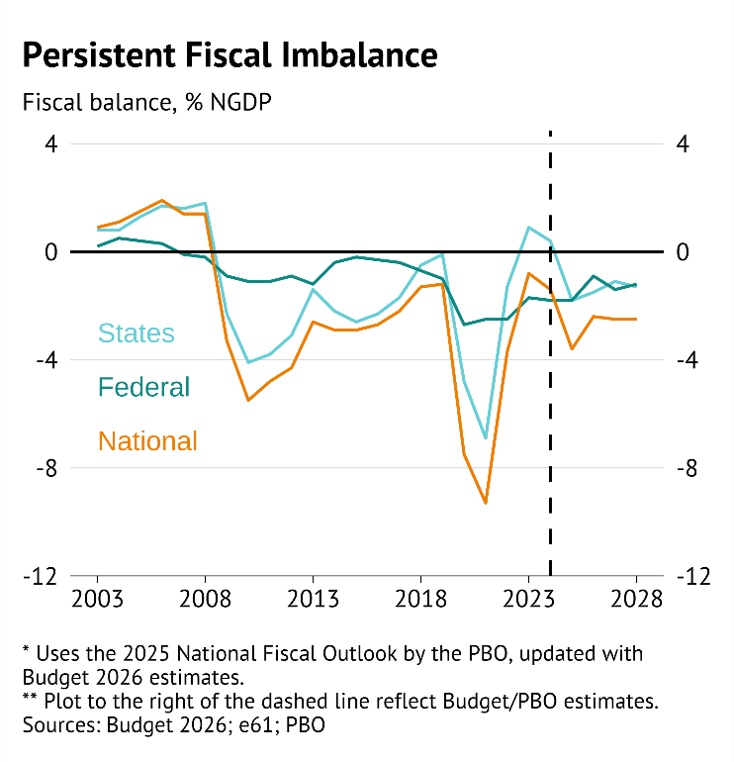

Figure

Given this, total net debt across state governments is expected to keep rising, reaching 13.8% of GDP in the 2028 FY – increasing consolidated net debt to 36.9% of GDP (Figure 3; PBO, 2025).

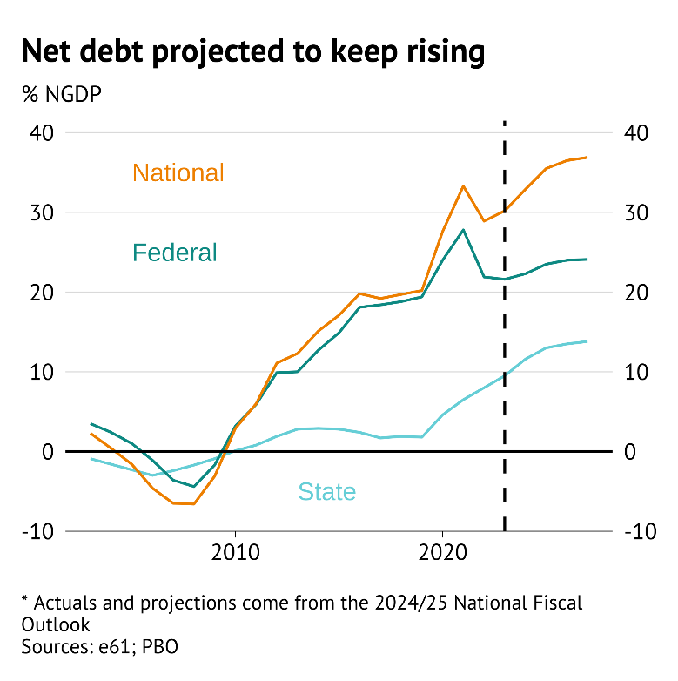

Figure

When looking at consolidated debt, the relative position of Australian government borrowing also changes. Between 2007 and 2016, Australia consolidated public gross debt was near the lowest of all countries measured by the OECD. In 2023, general government debt position had risen to around the middle of the OECD – with consolidated gross debt at 55% of GDP in 2023, 25th among 42 countries.[2]

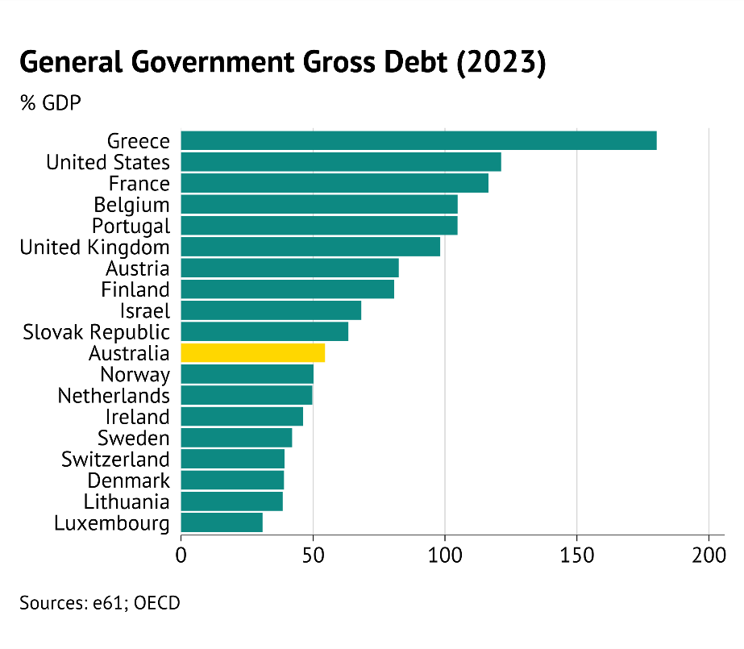

Figure

## Expenditure and revenue trends

Rising government debt has been driven by elevated consolidated expenditure. In 2024, expenditures including investment were 3.5 percentage points (from 36.3% to 39.8%) higher relative to GDP than they were twenty years prior – with two upward step-changes in spending following large crises (the Global Financial Crisis and COVID pandemic).

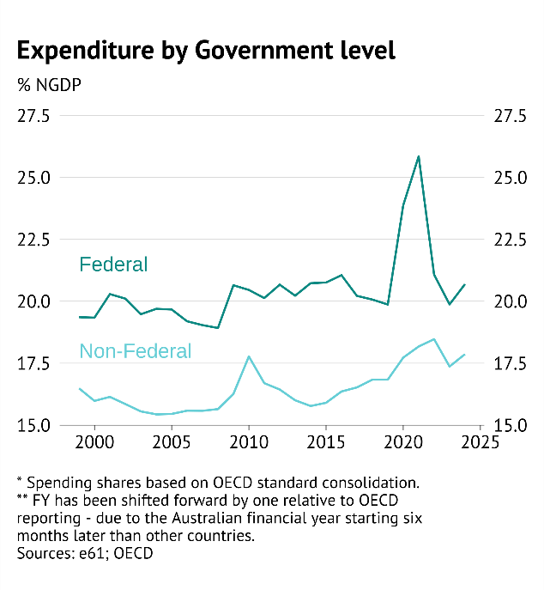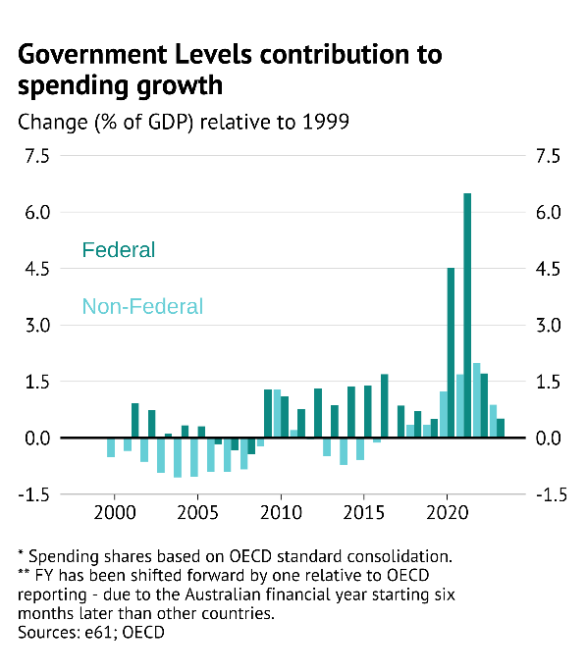

Figure

**Higher expenditure has been predominantly a federal issue**, with elevated spending both after the Global Financial Crisis and during the COVID pandemic largely due to federal provision and payment for services. However, non-Federal spending has also been persistently higher since the pandemic (Figure 5, panel B). [3]

A major driver of the increase in government spending has been a lift in the net acquisition of non-financial assets – or government investment. Higher investment accounted for 49 percent of the lift in spending to GDP, with current government expenditure accounting for the remainder.

However, this does not imply that the varying levels of government have had full discretion around increasing spending. State spending has been especially exposed to *demographic drivers* such as population ageing and unanticipated population growth that have increased spending pressures. Furthermore, the federal government has been increasingly providing tied funding to states to deliver services, or directly fund services themselves through in-kind transfers.

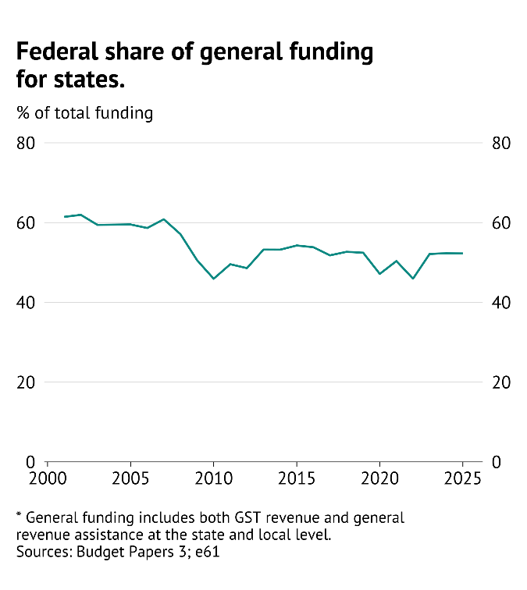

Figure

On a consolidated basis **general government revenue growth has been strong**. In 2024 consolidated revenue was nearly $979 billion or 36% of GDP, with over $800 billion of this raised from taxes.

OECD consolidation revenue attributes GST revenue directly to state governments, and as a result federal revenue here excludes income that they will grant to states.[4] The OECD breakdown in Figure 7 shows that revenue as a share of GDP in 2023 was 1.6 percentage point higher than in 2019. This increase was due to both increased federal (up by 0.9 percentage points) and state (up 0.7 percentage points) revenue.

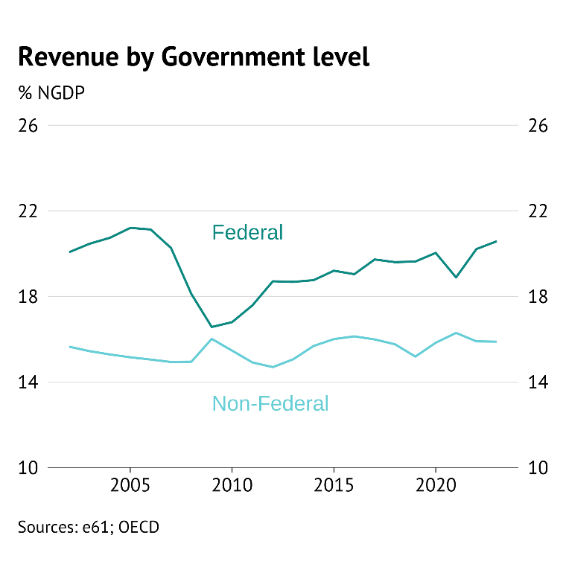

Figure

Although this growth makes current revenue look high relative to 2019 (prior to the COVID pandemic) such revenue is not without precedent. Prior to the Global Financial Crisis all-of-government revenue was at similar levels due to a tight labour market and high export prices – the same factors driving up revenue in recent years.

## International comparisons

The relative importance of local, state, and federal government in Australia can also be seen by looking at international comparisons of government spending.

These comparisons show that the contribution of non-Federal expenditure to overall spending is relatively large in Australia. Even so, **after consolidation government expenditure in Australia is still lower than most other OECD countries** – in 2022 consolidated government expenditure spending was 38% of GDP, the fifth lowest out of 26 countries.[5]

A similar story holds for revenue, with state and local government taxes a relatively large share of total revenue compared to most OECD countries.[6] Relative to subnational authorities in other jurisdictions, Australian states have significant autonomy over the taxes they levy – in terms of design and the rates charged. However, they do not have much control over the significant revenue provided from the Federal government – both untied GST receipts and revenue tied to service provision.[7]

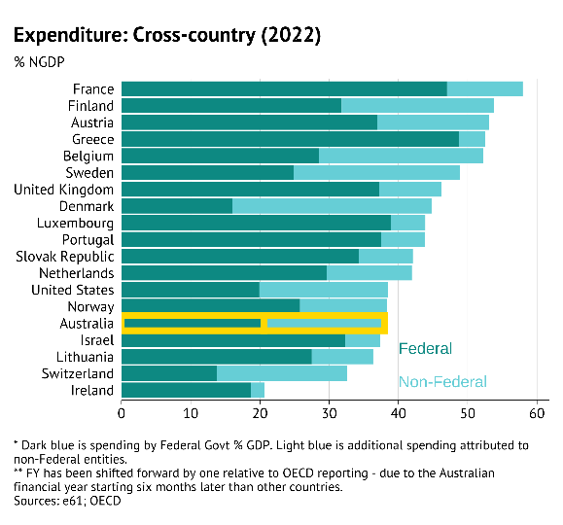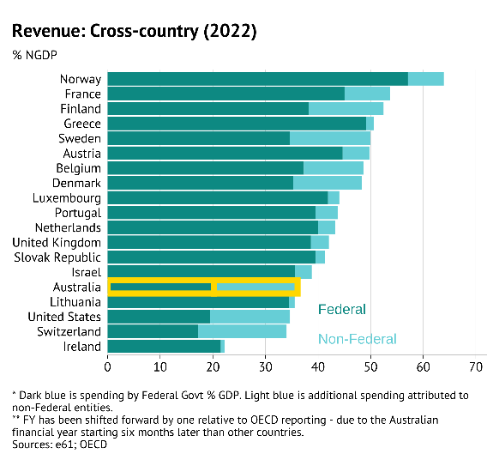

Figure

Although expenditure and revenue are on the lower end of the OECD, Australia has been ***converging*** to other OECD countries in terms of the size of government. This is illustrated by comparing spending trends in countries that were high spending in 1999 to those that were not.[8]

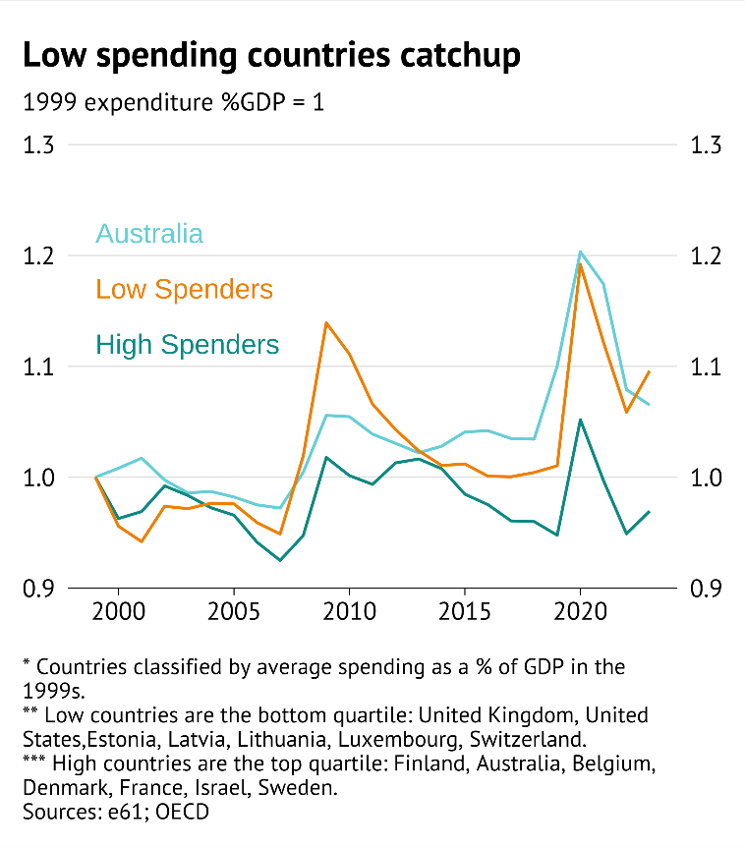

Figure

However, expenditure growth through the 2010s in Australia has **exceeded what we would expect from convergence alone**. To investigate this we use a synthetic control design to evaluate how government spending to GDP changed after 2008 relative to a synthetic Australia. The synthetic Australia is constructed using countries with similar age and spending profiles to Australia’s prior to 2008. Details of this exercise are given in Appendix A.

This exercise shows that overall spending growth (relative to GDP) was stronger in Australia than in comparison countries after the end of the mining boom in 2012. In 2019, prior to COVID, spending was 10% higher than comparison countries, and remained 9.5% higher in 2022.

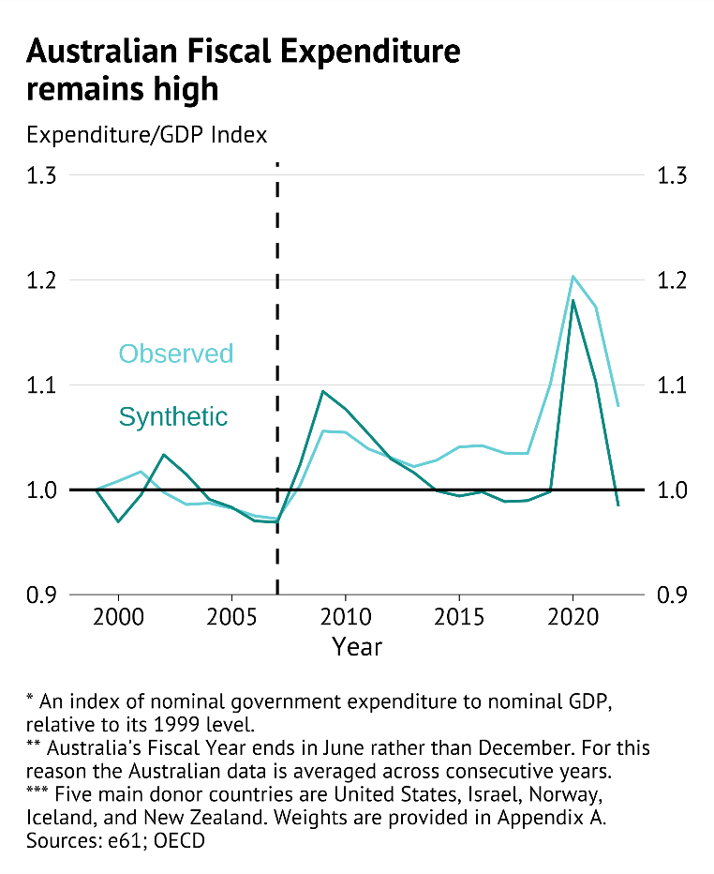

Figure

At face value this exercise suggests that **Australian government spending climbs in a similar way to other countries during a downturn, but does not decline during the subsequent recovery**. However, this interpretation is complicated by changes in export prices – the reduction in export prices from 2012 reduced nominal GDP in Australia. As a result, it appears both stickiness in spending from the government response to the Global Financial Crisis and expenditure habits that developed from a period of high commodity prices both contributed to elevated expenditure.

Overall, the economic environment and nature of public spending choices in Australia have led to a persistent lift in government spending shares after the Global Financial Crisis that was not observed in other countries. What these economic and policy drivers are is the focus of the rest of this document.

## What spending items matter

The consolidated accounts change our understanding of what the Australian governments spend on. The OECD provides consolidated government accounts up until 2022 by the *function* of government expenditure. These figures reflect both current expenses and net acquisition of non-financial assets. They determine the government level where the spending occurs, on the basis of where the final service is delivered – thereby attributing federally funded programs delivered by states at the state level.

Figure

In 2022, federal expenditures were dominated by social protection (including the NDIS), with 43% of federal spending taken up by this category (Figure 11). However, this is because social protection programmes are administered by the federal government – when looking at consolidated fiscal accounts social protection’s share of total spending is lower at 26%.

The consolidated picture highlights the importance of other direct service provision categories for government – such as health and education. Broader industry and labour market assistance (economic affairs) was also a large component of spending in 2022 – however this was somewhat inflated by remaining COVID supports paid through businesses.

Australian Bureau of Statistics (ABS) data on consolidated government functions allows a comparison of consolidated spending between 1999 and 2024 (Figure 12). The figures reported from the Government Finance Statistics (GFS) only include current expenses – this helps determine how much of the differential trends in expenditure activity may be driven by investment activity.

Overall, apart from a much smaller share of spending on economic affairs this approach gives a similar story.[9]

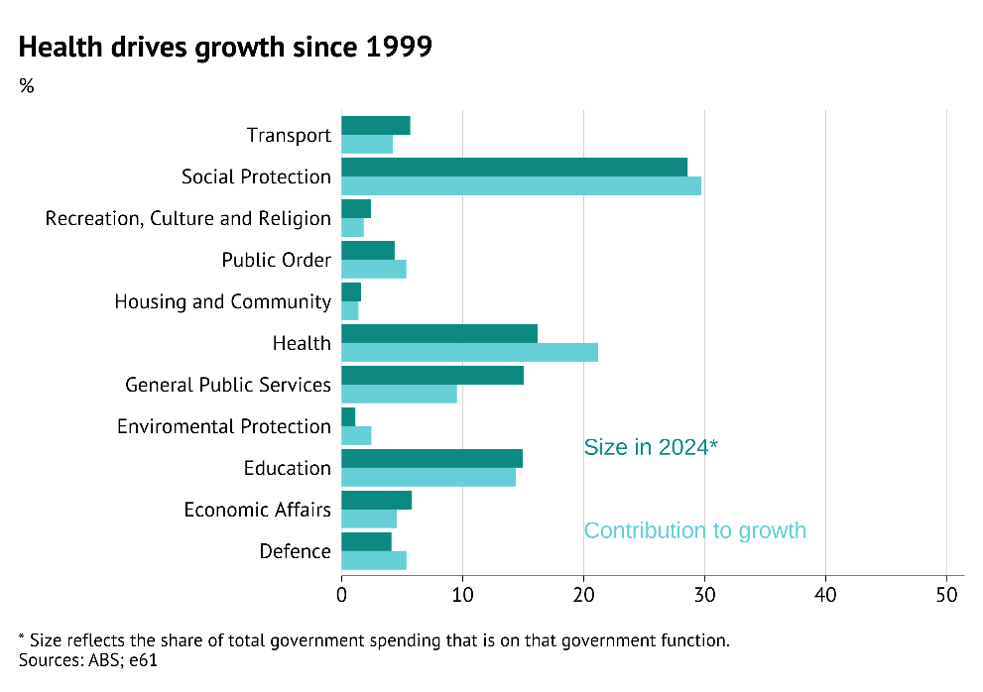

Figure

Across these measures two trends stand out regarding the relative size of government – a sharp increase in health spending and a decline in general public services. Since 2014, the spending shares have been roughly constant (Figure A.X), indicating that much of the change in government expenditure shares is an earlier story.

The reason for rising health expenditure was relatively broad-based with support for the take-up of private health insurance, additional hospital funding, and initial costs from reforms to pharmaceutical funding. The decline in general public services is related to a decline in the interest bill of government in the early 2000s as net debt declined.

Understanding more about these consolidated expenditure functions will be the focus of the **Profiling major spending categories** section.

### Government input expense types

Another lens for considering what governments are spending on is to look at the relative expenditures on varying *inputs* that are used to deliver the functions above. We split expenses into five categories:

1. **Interest**: Interest expenses reflect the gross interest payment of government entities (excluding intra-governmental transfers).
2. **Depreciation**: Depreciation reflects the usage of a capital asset, and thereby the reduction in the value of that asset due to use.
3. **Employee**: Employee expenses reflect the compensation provided to employees through wages, superannuation contribution, and fringe benefits.
4. **Non-employee**: Reflects other non-capital expenses needed for providing government services – this can reflect consultant fees, ICT development, maintenance expenses, supplies, and in-kind payments for private service delivery (i.e. NDIS).
5. **Transfers**: Direct income payments to households and firms.

The share of varying costs is shown in Figure 13.

Figure

Expense data indicates that employee expenses and transfers have fallen as a share of spending over time, while the share of government spending on non-employee expenses has risen from 27% to 36%.

Non-employee expenses refer to both payments for goods and services (i.e. payments to consultants, or IT service providers) and direct payments to the private sector for household services (i.e. child care, or rehabilitation services). As a result, cost pressures in this item could imply that expenses for government provision are rising or that the government is paying more for private services for households.

In-kind payments for households through programs like the NDIS and more generous child care provisions – not expenditure on consultants and ICT – are the key driver of this expense category (Figure A.XX). The increase in the share of in-kind payments accounted for 58% of the overall increase in the share of non-employee expenses. In the absence of this shift, this expense category would have only risen to 31% and overall government spending would be 5% ($54bn) lower.

### Grouping government spending categories

Government spending has a number of important purposes – from providing public goods (i.e. enforcing law and order, provision of infrastructure), supporting households and firms through their life with transfers (i.e. the aged pension), and providing direct services for households (i.e. health, education, and child care).

Classifying spending into each of these categories illustrates that the aggregate share of spending in these categories – at a consolidated level have been roughly similar over the past 25 years. A subtle change has been an increase in direct payments, due to increasing expenditure on health care.

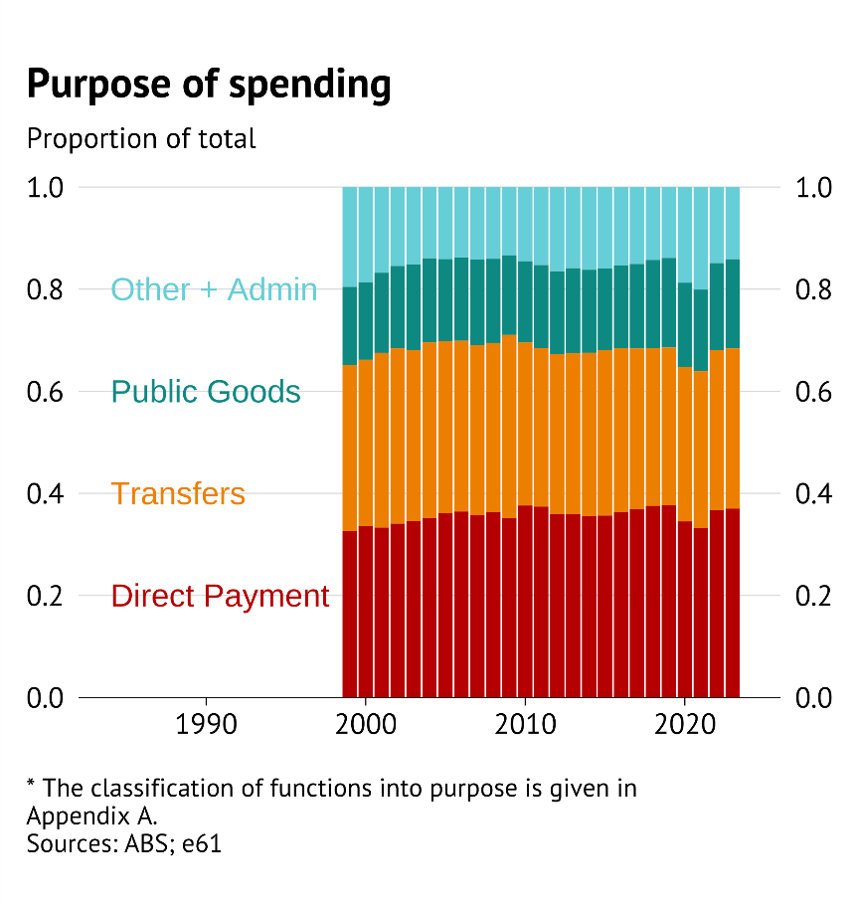

Figure

This framing also highlights that transfers and provision of services (either directly or through payments to private providers) account for most of the consolidated Budget. This constitutes support for varying lifecycle risks (i.e. poor health, job loss, income shocks) and support to help individuals get a fair chance in life by supporting minimum standards (i.e. education and childcare expenses).

The quality of spending thereby depends on how well these policies support lifetime outcomes, protect against lifecycle risks, and the cost associated with doing so.

Another way to group spending categories is to ask which **government functions** have evolved together. If certain categories tend to move in a similar way through time, this suggests that they are serving a similar purpose and experience similar drivers. This approach is shown with a hierarchical cluster mapping of categories, based on how spending has evolved over the past 25 years.

Figure

This cluster map tells us which types of spending have moved together over time in Australia. Clusters with a similar colour have been grouped together. However, we can also judge the similarities between items within and between clusters by looking at their relative position in Figure 15. For example, other social protection and unemployment payments are fairly distinct, but are more distinct from the other cluster categories. More details can be found in Appendix A.

Using cluster analysis to group categories suggests that consolidated public expenditure can be split into five broad clusters which have shared underlying trends and drivers. These are groupings related to:

1. **Cyclical social protection** (unemployment, economic affairs, other social protection),
2. **Youth and medical investments** (Family, education, environment and culture),
3. **Infrastructure and hospitals**,
4. **Public order and old age**,
5. and **housing transfers**.

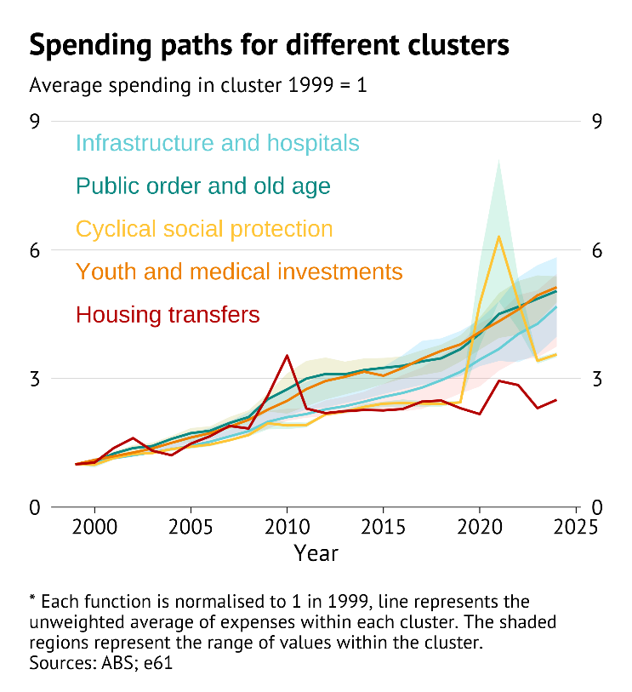

Figure

The time series of these clusters show that financial supports for working aged individuals – either through housing or income transfers – have lagged the increase in other broad sectors. Furthermore, spending on general infrastructure and hospitals also grew weakly, before picking up from the late-2010s.

Broader investments intended to support either young (education) or older individuals (specialist medical equipment) have both experienced strong and stable growth over the entire 25-year period.

The changing structure of government expenditure leads to the question of what drives this growth. Understanding the drivers informs whether such patterns are wasteful, and whether they are likely to persist.

# The birds eye view – economic transition and its implications

The size and persistence of governments deficits depend on economic conditions. Economic conditions both directly influence borrowing (by changing spending and revenue) and influence the political reality of how policy decisions are made. Structural headwinds that generate persistent deficits can make a country vulnerable to economic shocks, creating fiscal sustainability concerns.

Traditionally, structural headwinds have been viewed in terms of the three P’s: participation, productivity, and population (IGR 2023). However, over the last two decades three other significant trends have emerged – prices of exports, policy stickiness, and pressures external to the Australian Government (such as climate change, tariffs) – giving policymakers six P’s to grapple with.

1. **Population**: Population ageing has been a key driver of rising government expenditure over the last 15 years. This trend will continue and, with slower population growth, will act as a drain on government finances in coming years.
2. **Participation**: Rising labour force participation by older Australians has helped to mitigate the economic and fiscal effects of ageing. Participation among those aged over 65 would need to double to continue this trend.
3. **Productivity**: Australia’s weak productivity growth has reduced tax revenue as well as limited the economic opportunities for Australians.
4. **Prices of exports**: High and rising export prices have supported incomes as productivity growth has slowed. However, further increases cannot be relied on while the current high level of prices increases the risk of a downward correction.
5. **Policy stickiness**: Government expenditure has tended to move in line with prior GDP trends – even as productivity and GDP growth have declined. Difficulty adjusting spending to economic shocks increases concerns about the outlook for productivity and export prices.
6. **Pressures**: Climate change, a more restrictive trade environment, geopolitical instability, and financial market uncertainty are all heightened risks that require government headroom.

Evaluating these factors highlights that ageing is a dominant reason for recent increases in spending. However, **a 30-year loosening in fiscal discipline when the government revenue position was strong has placed Australia in this position**.

## The drivers

### Reframing the traditional P’s – the importance of ageing

The ability for a government to raise revenue and the use of this revenue depend centrally on the number of people, how much those people participate in economic activity, their ability to create when they do participate, and the needs they have. Population, productivity, and participation form the structure around how this happens (IGR, 2023).

Population growth in Australia has averaged 1.4% p.a. over the past three decades, a robust rate of population growth that has helped to support overall economic growth even when growth in per person activity has cooled. Population growth is expected to decline from these levels over the coming years, falling below 1.0% pa in 2035 and below 0.5% pa by the late 2060s.

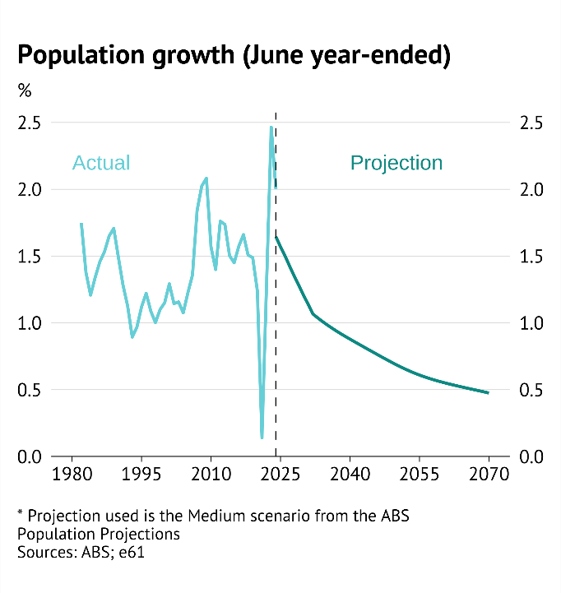

Figure

How this population growth translates into national income depends in part on the age structure of the population. A society with high dependency ratios – either due to large numbers of children or retirees – will have less capacity to produce income than a society with more working aged people.

Population ageing had, through the 1990s and 2000s, contributed to higher economic activity by lifting the number of working age individuals. But during the 2010s this trend turned. Current projections show both a significant ageing of the population and an increase in dependency ratios over the next forty years.

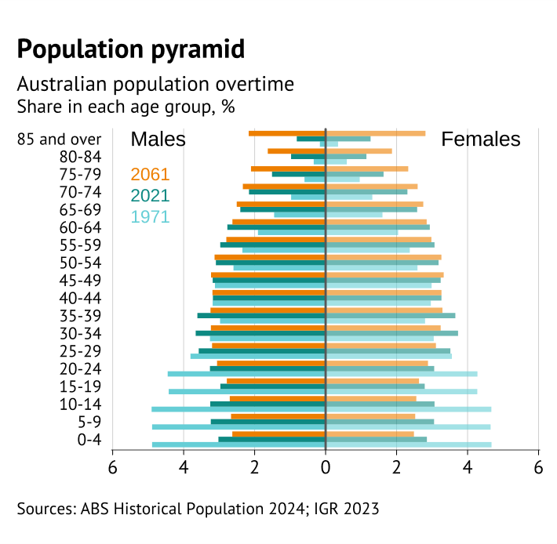

Figure

The growing population of older Australians matters for a number of reasons. Older individuals purchase different things, work in different ways (if at all), and require different medical and social support services. Specifically, the ageing population increases demand for many expensive government services (e.g. health care) and reduces the proportion of the population working – which in turn reduces the tax revenue needed to pay for these services.

Part of the reason why population ageing has not yet had a larger drag on tax revenue has been rising labour force participation among older Australians.

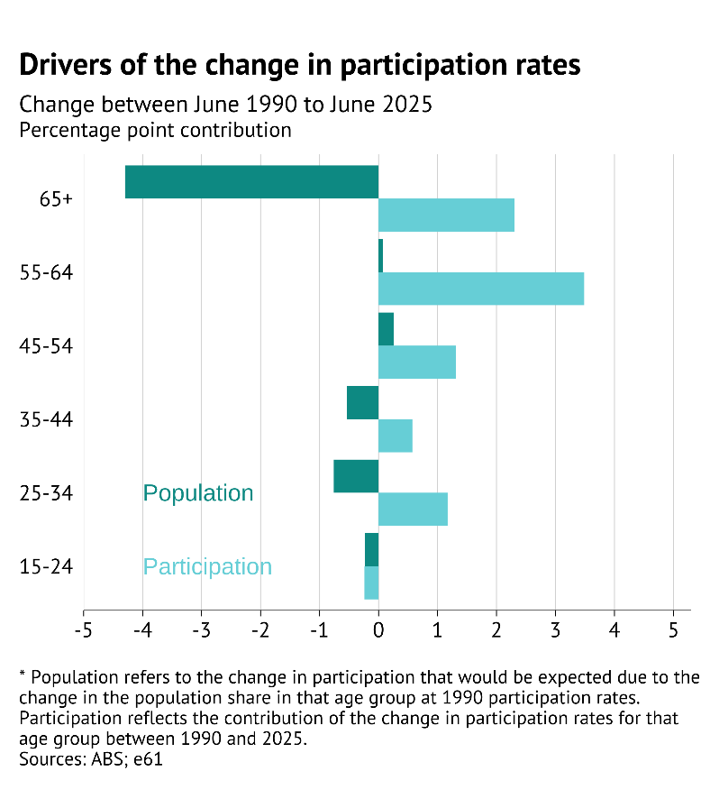

Figure

Rising participation, especially among older women, has increased the number of people in the workforce (Akyol and Gibbons, forthcoming). Rising longevity and the increase in the age of eligibility for the Age Pension have helped to support this rise in participation – with longer lifetimes and later government support making continued labour market attachment attractive.

Figure

However, the productivity slowdown is not an ageing story. The evidence of a relationship between ageing and productivity is mixed. Instead, the key driver appears to be a global slowdown in technological advancement combined with domestic factors such as a more restrictive regulatory environment.[10]

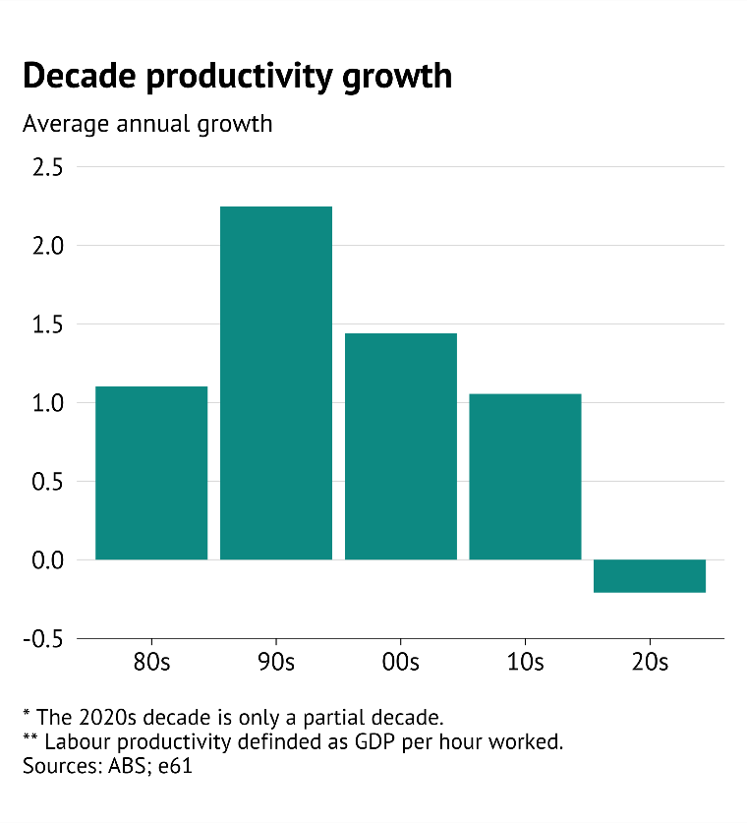

Figure

Low productivity growth matters in this context because it is diminishing Australia’s ability to finance the cost of ageing. Policy settings that were established for a world with 1.5% productivity growth become expensive, and intergenerationally inequitable, in a world without such growth.

### The role of new P’s: Policy inertia meets falling productivity

In recent years slowing productivity has been papered over by a rising terms of trade – allowing national income to continue rising at a modest rate. Current GDP per capita is 3.2% higher than its pre-COVID level, while income measures that include the boost from the terms of trade – like real national net disposable income (RNNDI) – have risen 5.6%.[11]

The lift in export prices has been favourable in terms of boosting Australians’ living standards and fiscal space, but also highlights a continuing risk for the economic and fiscal position.

Figure

As growth in economic activity has slowed, consolidated expenditure has continued to rise in line with prior spending and economic growth. This suggests a degree of stickiness in spending behaviour – where prior expenditure habits and implicit rules drive future government expenditure (Figure 23). Barnes, Cournède, and Pascal (2023) find evidence of such stickiness across OECD countries, and determine that difficulty cutting nominal spending – even if the need for a program has disappeared – is the key driver of such stickiness.

Figure

These expenditure habits at a consolidated level suggest that there are fiscal arrangements that continue to increase spending, even as the capacity for the government to fund this spending and the need for that expenditure change. Such stickiness is especially apparent in government functions where there are political pressures associated with reducing headline spending – like education – a tendency that is discussed further in the **Education function** chapter.

Sticky government expenditure combined with weaker productivity growth and already high commodity prices leaves Australian in a position where it is vulnerable to economic risks.

### How important are these factors?

Broad-based policy pressures and inertia are clear when decomposing the drivers of the change in current spending to GDP between ageing, economic, and residual (policy) based factors. The approach is discussed in greater detail in Appendix A.

Figure

This decomposition reflects the association between varying economic trends and the change in government consumption as a percent of GDP. In each case the association could be driven by a driver that increases shocks (such as an increase in older people who tend to use more government services) or by an associated policy decision to increase spending (such as a decision to lift per-person support for old-aged care as more individuals require it).

Since 2013 – when dependency ratios were starting to rise – the contribution of the over 65 group to spending pressures also rose. In this way, fiscal pressures over the last decade have been strongly related to an ageing population. The specific drivers of this are covered in more detail in the Health and Social protection sections.

Between 1990 and 2000, Australia was benefiting from a demographic dividend – with ageing effects subtracting from government spending. During this time a mixture of spending increases and rising government costs combined to increase expenditure. In the 2001-2011 the demographic position started to turn while policy decisions aimed to reduce costs – although this combination helped to restrict spending growth relative to GDP, rising labour force participation and a surging terms of trade made this process easier.

This suggests that the **broad fiscal environment that has led to a loosening in fiscal discipline has been underway in Australia for nearly 30 years**. However, until 2011 this had been hidden by a positive demographic dividend which was placing downward pressure on spending and inflating government revenue.

## The implications

### The role of ageing

The implications of ageing on the Federal Budget are comprehensively discussed in the Intergenerational Report (IGR). However, there has been little analysis of whether the same trends exist for consolidated fiscal accounts.

Based on the prior decomposition it is possible to consider a counterfactual where the age distribution was unchanged, but other economic characteristics were allowed to vary.[12]

This suggests that pressures associated with ageing – due to growth in the number of people, growth in costs due to higher demand, and policy responses when faced with an ageing population – have increased government consumption expenditures by as much as 5% GDP.

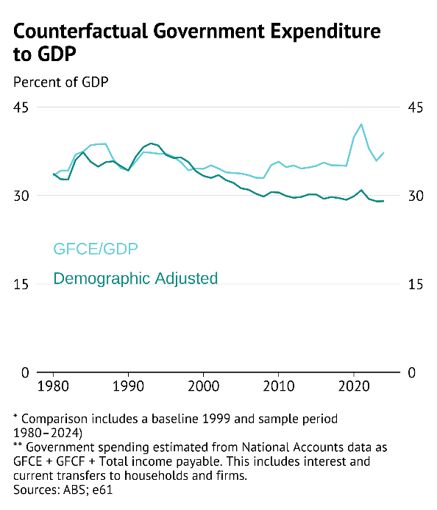

Figure

Such an estimate assumes that other spending pressures were independent of the effect of ageing. However, this is unlikely to be the case as ageing reduced fiscal space and has forced a reduction in other forms of government consumption – in this context the net effect of ageing on spending is likely to be smaller. How this has taken place in health and social protection is outlined in greater detail in the **Health function** chapter.

Given this approach we can project what government expenditure would look like through to 2071, based on external estimates of the ageing of the Australian population and the evolution of export prices. These projections are indicative and **should not be read as detailed forecasts of future general government expenditure**.

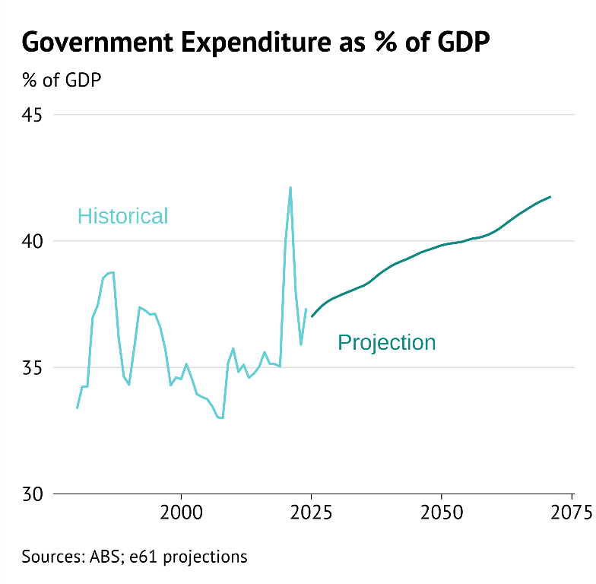

Figure

Projections suggest a substantial increase in government spending to GDP over the next decade due to multiple headwinds – a falling terms of trade, rising relative prices for government services, significantly slower population growth, and a sharp increase in the share of Australia that is aged over 65. This increases the national accounts measure of general government spending from nearly 38% of GDP to 40% of GDP by 2035.

However, it isn’t just a rise in dependency ratios that drive up government expenditure in this approach.

Between 2035 and 2050 the dependency ratio settles at a higher level, while the proportion of prime/mature age workers rises – providing a second wind for the Australian consolidated fiscal position. However, this is only temporary with a further increase in dependency ratios increasing government spending back towards 40% of GDP.

### The role of economic risks (federal level only)

Economic shocks, by their nature, are hard to plan for. However, due to the insurance nature of government, assessing and allowing for these risks in the budget process is central.

At a federal level, the Budget and available tools provide significant information about potential economic and fiscal risks in Australia.[13]

These documents highlight risks to revenue and expenses, contingent liabilities, and contingent assets of sufficient magnitude, as identified by the line agency responsible. Furthermore, climate change related fiscal risks are separately identified and discussed.

The Budget discusses and quantifies specific economic risks associated with the outlook, and it illustrates sensitivity to export prices, interest rates, and general uncertainty around the forecasts.[14]

We can highlight some of these downside risks on the Federal Budget by utilising the Parliamentary Budget Office (PBO) Build Your Own Budget tool. This tool allows the user to adjust underlying economic assumptions and trace through their mechanical effect on federal government budgets – noting that adjustments by both the government and private sectors are not incorporated.

Below we consider cascading sets of expenditure and revenue risks.

Figure

Some of these risks are likely (e.g. lower productivity growth) while others are unlikely (e.g. the sharp decline in export prices). However, a clear take-away from these scenarios is the importance of productivity growth – which has a compounding effect on the government budget through time. If net migration is restricted and productivity growth is half of current projections (0.6%pa instead of 1.2%pa), then gross debt would rise to 46.3% of GDP by FY36 relative to current forecasts of 31.8%.

When describing these risks any large and persistent change in economic activity was not accounted for. This can be important when a shock in one domain (i.e. a sudden rise in interest rates) passes through into other parts of the economy.

To consider the importance of indirect economic effects, we consider the estimated change in gross debt ratios from a temporary 150 basis points increase in global interest rates. In this instance, the increase in the global risk-free rate which passes through into a similar increase in the Australian government 10-year bond rate. The calculation of this shock is described in Appendix B.

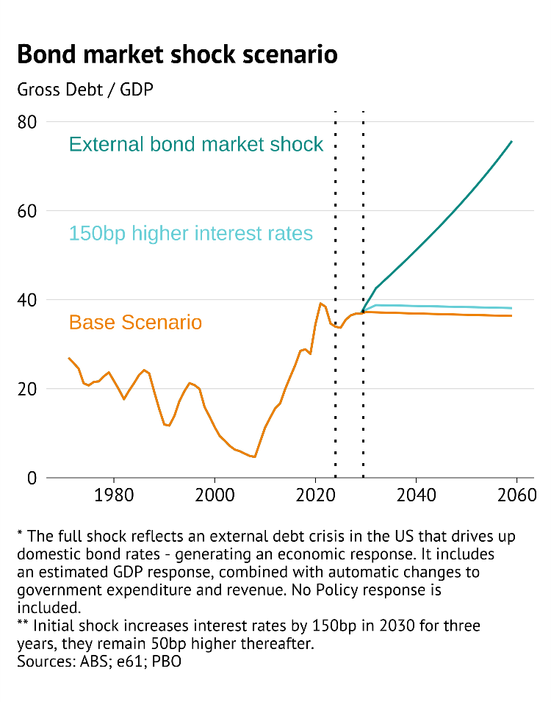

Figure

With no economic or policy response this would lead to a 7 percentage point increase in gross debt to GDP (from 36% to 43%) relative to projections in thirty years (2055). However, once the expected effect on economic growth, and thereby revenue and spending, are taken into account the gross debt position would increase by nearly 20 percentage points to 56% under status quo policy settings.

# Profiling major spending categories

Below we will describe the importance of *consolidation* in understanding spending trends in five major spending *functions*: health, social protection, economic affairs, defence, and education. We will also show, at a high level, how such consolidation influences benchmarks and projections associated with each spending item.

Doing so will show the importance of looking at an all-of-government Budget and balance sheet when considering matters of fiscal sustainability, and also highlight institutional difficulties that can prevent value for money spending adjustments.

Investigating these spending functions suggests that:

* **Health spending pressures** have been greater than Federal statistics alone suggest – with most of this pressure driven by the ageing population. On current trends, public health spending is likely to reach 10% of GDP by 2060 – up from 7.1% currently.
* **Social protection spending** has shifted from targeted poverty reduction programs to in-kind service provision for specific needs (such as disability and child care). This shift alongside population ageing is expected to increase social protection spending as a share of GDP.
* **Economic activity spending** generally grows in line with GDP in Australia, but rose sharply during the COVID pandemic due to JobKeeper. This differs from other countries, who more readily use job retention and business support during downturns. As long as wage subsides are business bailouts are limited in the future, fiscal pressures from this function will be unlikely. (discussed in Appendix B)
* **Defence spending** has been increasing but remains below the 2.5-3% target raised by foreign stakeholders and some politicians. Even at its current level the sector is showing signs of capacity constraints and inefficient cost pressures. Unless these can be mitigated there are value for money concerns in defence spending.[15] (discussed in Appendix B)
* **Education spending** has stayed at a constant share of GDP, even as an ageing population suggests that this function should have been growing more slowly – with spending 0.5% of GDP higher than demographics would suggest in 2024. If education spending following demographic trends it would be a further 0.5% of GDP lower in the 2050s – suggesting that current stickiness in education spending may raise value for money concerns.

Revenue trends are also important for fiscal sustainability, but are not the focus of this report. The costs associated with raising greater revenue to pay for potentially unsustainable spending are discussed in Appendix B.

## Health function

Rising health expenditure has been by far the largest single driver of consolidated government spending growth over the past two decades. It increased from 5.5% of GDP in 1999 to 7.1% of GDP in 2024 (Figure 29 panel A). This equates to an 87% increase in real annual public healthcare spending per person (or $3,270 in 2024 AUD).[16]

The growth of consolidated government health spending over the past 25 years has been so significant that it is the main driver of government spending growth rising as a share of GDP.[17] And while it may not receive the same level of media attention, the increase in health spending over this period accounts for almost the same share of GDP as the total level of spending on the NDIS (1.6% vs 1.7%; Akyol and Clarke, 2025).

Health is an area where considering consolidated spending matters. State governments now account for almost 60% of total health expenditure, up slightly from 56% in 1999 (Figure 29 panel B). Although some state expenditure is directly financed by the federal government,[18] focusing on federal government spending alone will underestimate both the scale and growth of government health spending.

For instance, Federal Treasury’s 2023 IGR shows federal health spending increasing from 3.7% of GDP in 2002-03, to 4.2% of GDP in 2022-23 (IGR, 2023). This equates to growth of only 0.5 percentage points of GDP, compared to an increase at the consolidated level of 1.3 percentage points as a share of GDP.

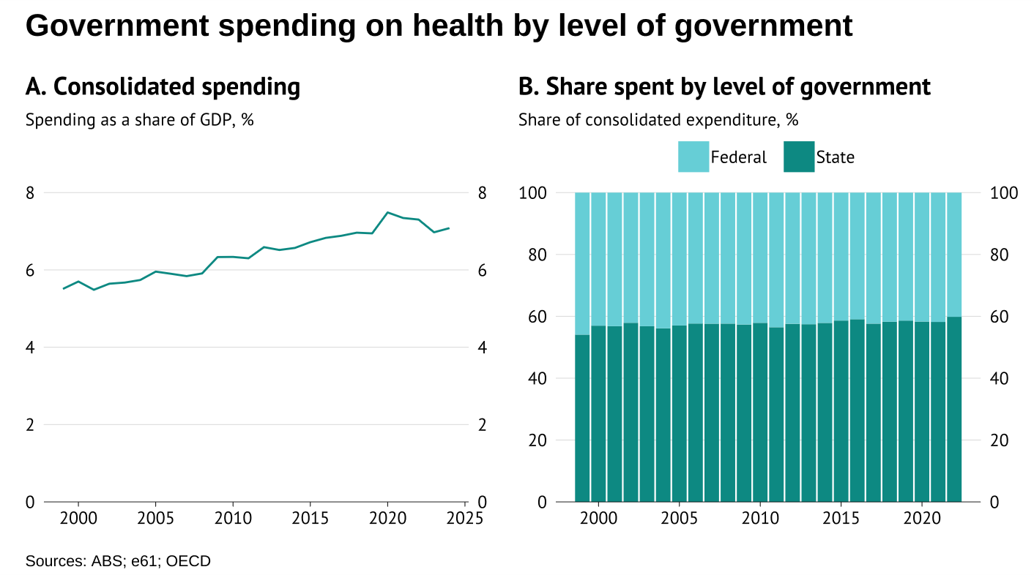

Figure

### Health spending growth is relatively broad based, with no one smoking gun

Government spending on health has increased as a share of GDP across nearly every Classification of the Functions of Government (COFOG) category of expenditure (Figure X.1 panel A). Spending in some areas, such as outpatient services, public health, and medical products, has grown more quickly than overall health expenditure. But even if these areas with above average growth had grown at the same rate as average health expenditure, consolidated government health spending would still have increased by over 1% of GDP from 1999 to 2024.[19]

On the input side, spending has increased across all expense categories and has also increased as a share of GDP (Figure X.1 panel B). While growth in labour expenses has outpaced growth in other categories, this faster than average growth accounts for at most 8% of the overall increase in health care spending.[20]

Combined, these trends in the components of health care costs highlight that spending pressures have been broad based rather than driven by specific functions or inputs.

On the demand side there is an elephant in the room: Australia’s ageing population. Between 2000 and 2022, the share of Australia’s population aged 75 and over increased from 5.6% to 7.6% (ABS, 2024). Ageing matters a lot for health care costs due to the greater health needs of older Australians. According to the Australian Institute of Health and Welfare, health care spending is more than 3.5 times higher for the average Australian aged 75 and over, compared to Australians under the age of 75 (AIHW, 2024).[21]

One way to look at the effect of ageing is to measure the direct contribution that ageing has to changes in real per capita spending. Under this approach, the ageing of Australia’s population only explains a relatively small share – roughly one quarter – of the growth in real per capita spending over the past 25 years (Figure X.2 panel A).

But this approach can be misleading. It assumes that rising incomes will not lead to higher health spending without policy change. Between 2000 and 2024, real GDP per capita grew by 33% (ABS, 2025). Had health spending remained at 2000 levels, it would have fallen as a share of GDP from 5.5% to 3.8%, a drop of about 31%. However, as Australia becomes wealthier it is reasonable to assume that the government would spend more on health services.

As a result, an alternative benchmark is to assume that, absent ageing and major policy reform, health spending would remain a constant share of income – this is the common benchmark used in fiscal analysis. The next section adopts this approach, comparing health expenditure against demographic change.

### Benchmarking health spending

In this section we benchmark Australia’s health care spending growth in two ways. The first method is a demographic benchmarking exercise where we predict how consolidated spending would have increased if spending on the healthcare of Australians of different age groups had risen overtime in line with GDP per capita. This is effectively an extension of a standard shift-share decomposition of ageing, but where the rate of expenditure for each age group is tied to GDP per capita.

The result of this demographic benchmarking exercise shows that between 2005 and 2024,[22] health care expenditure grew roughly in line with what a combination of population ageing and income growth would predict (Figure 30, panel A).

The second benchmarking exercise we conduct uses a synthetic control method to compare spending trends in Australia and countries with similar demographic and health care spending trends, which are represented by the ‘synthetic’ Australia (Figure 30 panel B).[23] This cross-country benchmark suggests that since 2010 Australia has seen much higher growth in health spending compared to other similar countries. While Australia’s consolidated government health expenditure grew by roughly 23% from 1999 to 2022, growth in similar countries, the ‘synthetic’ Australia, was only 12%.

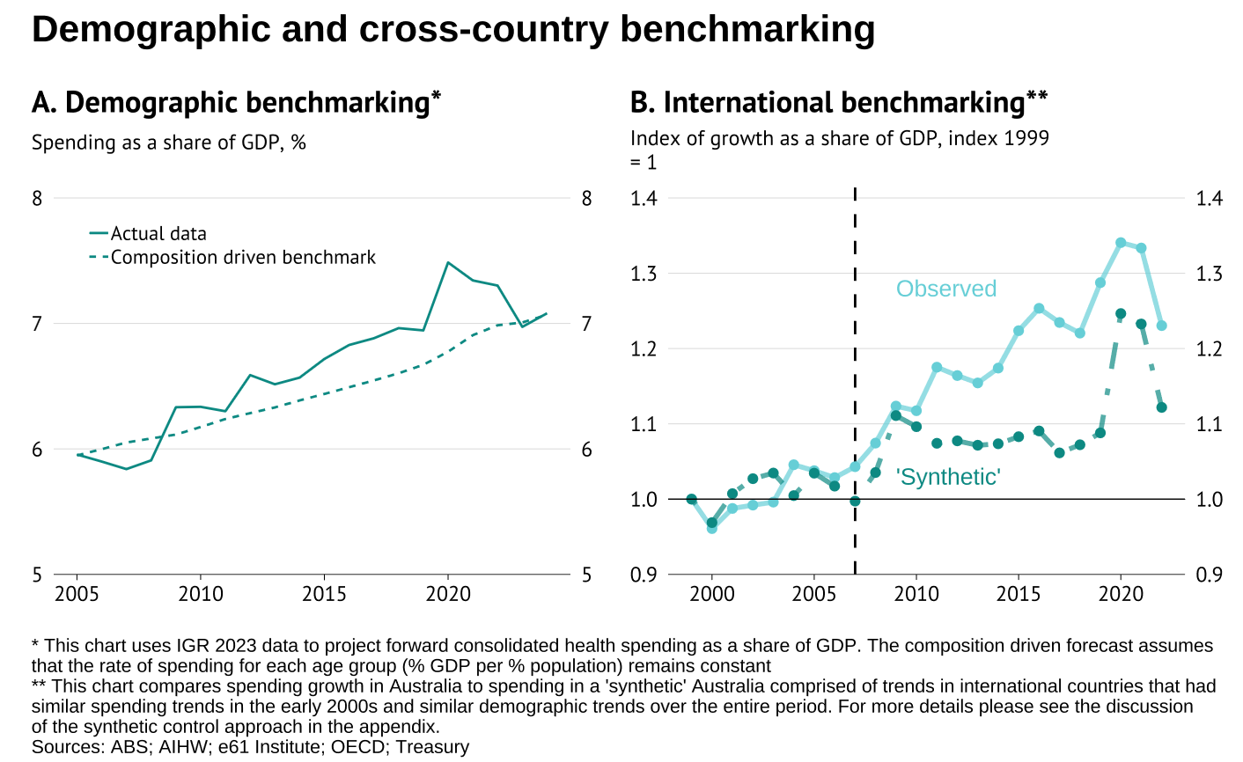

Figure

Taken together, these two benchmarks suggest that while much of Australia’s health spending growth can plausibly be explained by ageing, other countries that have experienced similar trends have increased their expenditure by much less.

What will happen if Australia continues to follow this age-linked growth trajectory? Over the next 40 years the share of the Australian population aged over 75 is predicted to increase from 7.8% in 2023 to 13.2% by 2063 (IGR, 2023). If spending on health care continues to increase in line with demographics and income, this suggests that expenditure will increase from around 7% to almost 10% of GDP in 2063, (growth of 34%) (Figure 31).

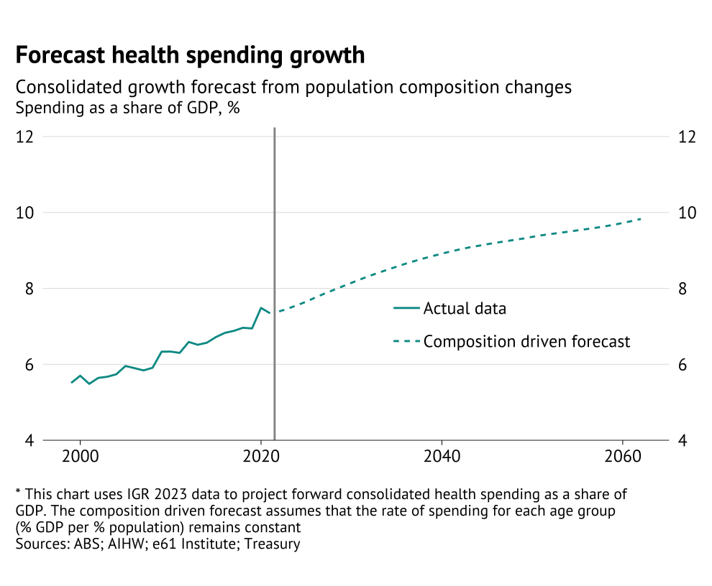

Figure

Notably, this age-based projection of health spending is lower than IGR forecasts, which suggest that consolidated government health spending will rise from 7.1% of GDP in 2024 to roughly 10.5% of GDP in 2063 (IGR, 2023).[24]

### Have health outcomes improved?

Has the increase in health expenditure led to better health outcomes? To measure health outcomes, it is important to capture both quantity (years) and quality (physical and mental health during those years). One metric that aims to capture both factors is healthy life expectancy (HALE) at birth. HALE is defined by the World Health Organisation (WHO) as the average number of years that a person can expect to live in "full health," taking into account years lived in less than full health (WHO, 2025).

Focusing on HALE suggests Australia has seen relatively little progress in health outcomes over the past two decades. HALE increased by only 2.5 years, from 68.1 in 2000 to 70.6 in 2021 ([WHO, 2025](https://www.who.int/data/gho/data/indicators/indicator-details/GHO/gho-ghe-hale-healthy-life-expectancy-at-birth)).[25] Of course, HALE would not be equal to zero with no health spending. Adjusting for this fact, the portion of HALE above this expected “base” HALE of about 44 years,[26] has increased by roughly 10% since 2000. But this is still far below the 90% increase in real spending per capita that occurred over the same period.

So, does this mean Australia is not getting value for money from increased health expenditure? Not necessarily. As noted in the prior section, higher spending is largely driven by demographics – individuals are moving into the part of their lifecycle where these expenses occur. Cost control measures implemented since the late 2000s to mitigate the effects of ageing may then have an unclear effect on value for money – with the magnitude of the increase in technical efficiency associated with Activity Based Funding reform the key metric for determining if there have been true increases in value for money (IHCPA, 2011).

Furthermore, a reason for the mismatch between spending growth and outcomes is that there has been an offsetting change in behavioural and environmental risk factors that have increased the rate and severity of disease. The [Productivity Commission found](https://www.pc.gov.au/inquiries-and-research/measuring-healthcare-productivity/) that allowing for this implied that health care productivity has risen by approximately 3% per year between 2012 and 2018.

## Social protection function

Social expenditure refers to government support for households, either in terms of income support or contributions towards private household services. Often these expenditures are directed toward groups with reduced work capacity or heightened vulnerability, such as low-income households, the elderly, people with disabilities, people who are unemployed, the sick, young people, and families with children. It encompasses cash transfers, in-kind goods and services, and tax breaks that operate as cash-equivalent support.

For decades, this has been the single largest component of the federal budget. State expenditure in this category is limited – at around 1% of GDP. State spending consists of support related to housing (i.e. aged care, homelessness), child protection, and some disability services. State spending has fallen from approximately 1.4% of GDP to 1% since the start of the NDIS.

Surprisingly, despite recurring public debates about “welfare dependency,” concerns over ageing populations, and the fiscal cost of payments, social expenditure as a share of GDP has been remarkably stable.

In 2001 expenditure stood at 10.4% of GDP and by 2024 it was also 10.4%. Over the intervening years, spending fluctuated within a narrow band of roughly 2 percentage points, trending down slightly during the 2000s, then up through the 2010s. The pandemic marked the main departure: expenditure peaked at 11.5% of GDP as income support expanded to cushion the downturn.

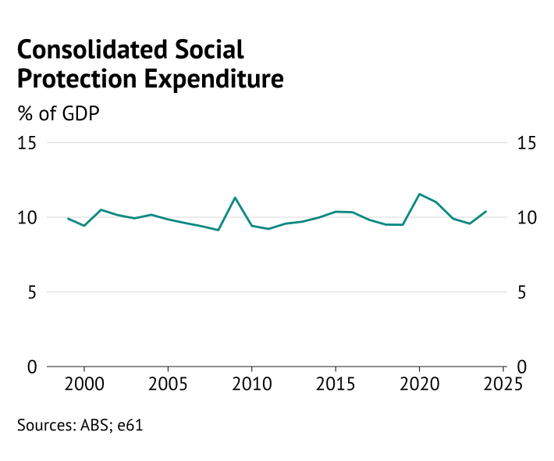

Figure

This long-run stability might suggest that social spending plays only a modest role in shaping Australia’s fiscal story. However, beneath this stability lie three structural shifts in the nature of these transfers that matter for both the fiscal outlook and the nature of the support being provided to households.

First, is a substantial shift in the types of groups that are supported. **Support for families has declined, while support for people with disabilities has grown**. Part of this is due to demographic factors – with falling fertility and the population ageing, this compositional shift is likely to continue, with family payments shrinking further and aged-related support expanding. However, the increase in spending on disability through the NDIS has exacerbated these trends.

Second, **policy has shifted from direct income support (cash transfers) toward in-kind services (such as subsidised aged, disability, or child care)**. This has important implications. Income support is tightly targeted to low-income households, whereas in-kind services are less targeted. Fiscal dynamics differ as well: income support payments typically are indexed to CPI, so decline as a proportion of GDP, while the cost of in-kind services tends to rise faster. This tilts the outlook toward stronger expenditure growth.

Third, **demographic change will lead to higher spending on social protection**. Ageing alone is expected to drive a sharp rise in aged care expenditure. At the same time, the NDIS has introduced upward cost pressures, both from enrolment growth and from rising services per participant.

While social expenditure has been flat for two decades, this series of factors indicates that **expenditure will rise over the next forty years under current policy settings**. The 2023 IGR anticipates that social spending will rise by around 1.6% of GDP over coming decades, driven largely by aged care and the NDIS.

### International Comparisons

Australia’s consolidated social protection expenditure is at the lower end of the OECD relative to GDP. However, this lower level of expenditure is similar to most Anglosphere countries, with expenditure to GDP slightly higher than in Canada, New Zealand, and the United States, but somewhat lower than the United Kingdom.

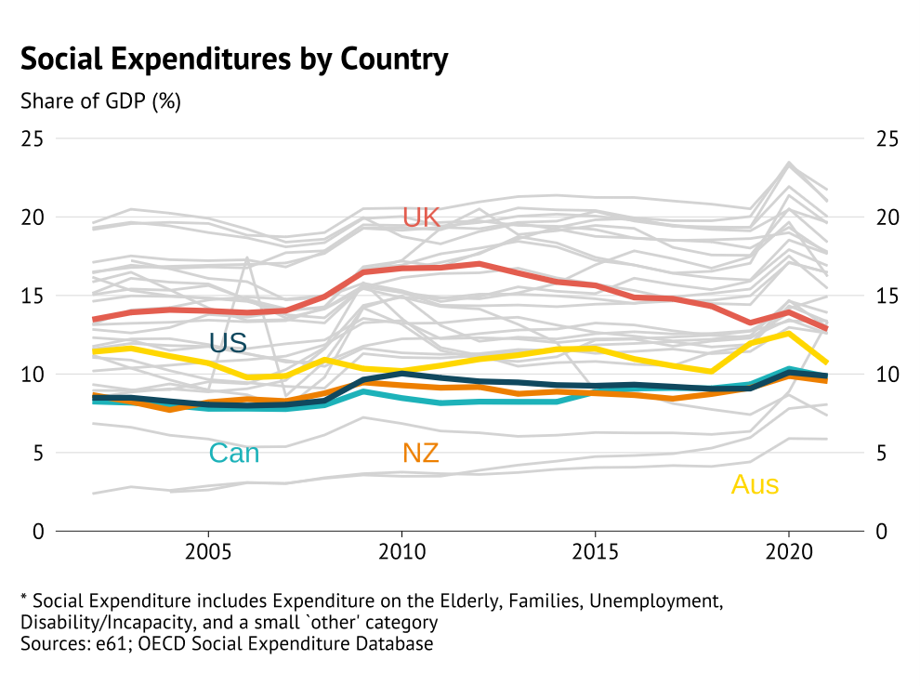

Figure

Anglosphere countries tend to *target* spending programs which partially explains lower overall expenditure. However, part of this apparent restraint is illusory. Australia has kept public spending on the elderly relatively low by shifting the burden to the tax system through the concessional treatment of superannuation contributions. Although most countries have some form of concessionary treatment Australian treatment of superannuation is [especially concessionary](https://www.oecd.org/content/dam/oecd/en/publications/reports/2018/12/financial-incentives-and-retirement-savings_g1g96ed9/9789264306929-en.pdf) compared to similar countries.

Conversely, Australia has relatively high levels of expenditure on disability related social protection. Outlays have surged with the rollout of the NDIS over the past decade, pushing disability expenditure to among the highest in the world. Only the Nordic countries spend more as a share of GDP on disability support ([OECD 2025](https://www.oecd.org/en/data/datasets/social-expenditure-database-socx.html)). By 2021, Australia spent roughly 1.1 percentage points of GDP more on disability/incapacity than the OECD average of 2.0%.[27]

### A shift in those supported

A major trend over the past decade has been the shift in who benefits from Australia’s social expenditure. Support for people with disabilities has risen substantially, offset by reductions in family payments and a longer-run decline in “other” benefits. [28] Disability support has increased by around 1 percentage point of GDP, while family benefits have fallen by about 0.4 percentage points. Meanwhile support for those experiencing unemployment has been relatively flat with the exception of the COVID pandemic.

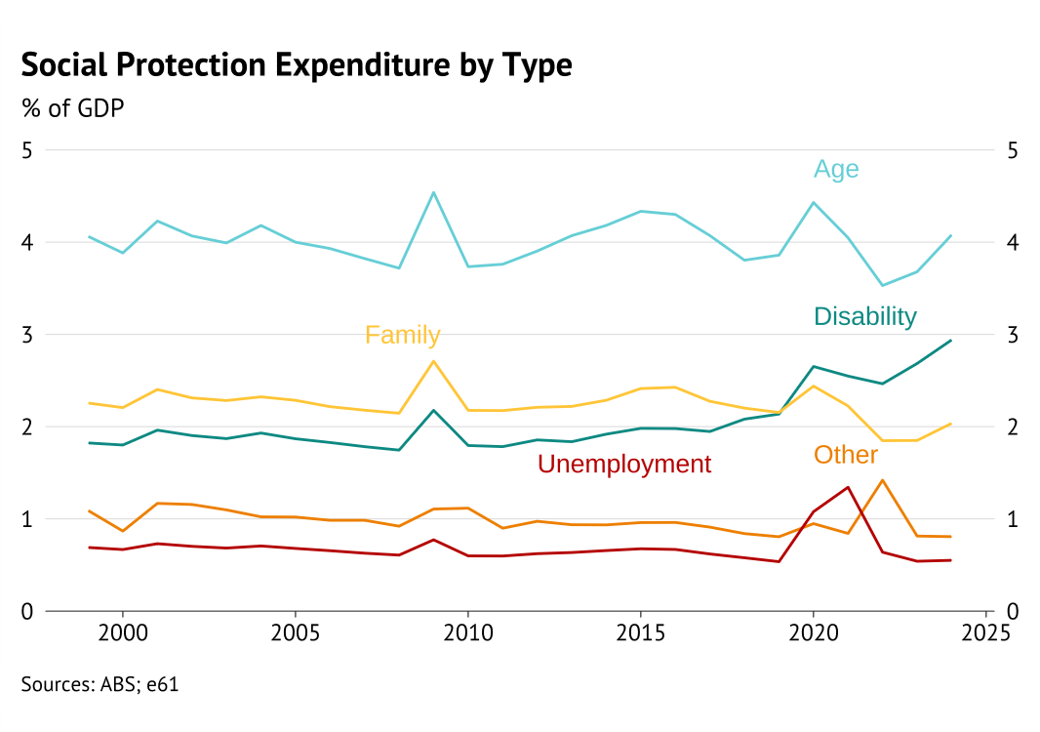

Figure

The fall in family support is largely explained by the decline of the Family Tax Benefit (FTB), the flagship program supporting families with children. FTB spending fell steadily from around 1.5% of GDP in 2000 to less than 0.7% today. Parenting Payments have also declined by about 0.5% of GDP. These reductions have been partly offset by expansions in in-kind services, including childcare subsidies and family protection programs. The only increase in cash transfers to families has come through the Paid Parental Leave scheme introduced in 2011.

Both policy change and demographics have played an important role in bringing about this change.

Successive policy changes during the 2010s tightened eligibility and reduced generosity of family payments, notably the shift in indexation from wages to CPI in 2009, and the introduction of income testing for FTB Part B in 2011.

However, **demographic change appears to be more important for explaining the decline in spending**. With fertility declining, the share of children under 16 has fallen from 23.6% of the population two decades ago to around 20% today. Adjusting for this change, family spending looks stable: up until the recent decline in FTB, demographically adjusted expenditure per child was actually rising through the mid-2010s, and now is roughly where it was in 2000. This contrasts with spending on aged care, which has risen sharply relative to an age-adjusted benchmark – due to rising costs of service provision.

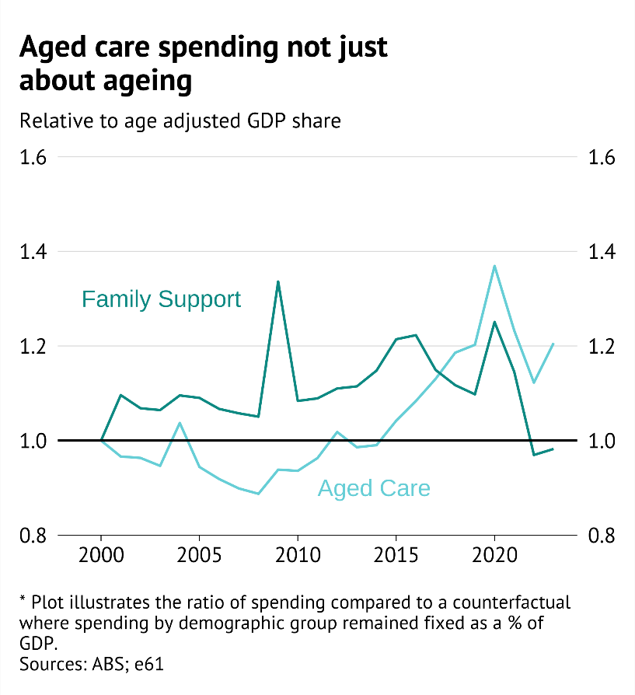

Figure

The **dominant growth story has been disability**. The introduction and expansion of the NDIS has increased disability spending by about 1 percentage point of GDP since the early 2010s. Importantly, much of this growth has been concentrated among young people. Children aged 0–14 account for the largest share of recent growth in NDIS outlays, meaning that some of the fiscal shift away from family cash payments has, in effect, been redirected toward in-kind disability support for children. The government has acknowledged this, but it is unclear how much the Thriving Kids program will bend the cost curve of in-kind support at this stage.

The lift in disability spending has occurred even as *income transfers* to those with a disability has declined. In 2014 significant changes to eligibility for the disability support payment were legislated, which has led to a gradual reduction in the proportion of the population that is in receipt of this payment.

### A shift in the types of support

A defining trend over the past decade has been the shift in the *type* of social protection Australians receive. Historically, Australia maintained one of the most targeted income support systems in the OECD. Means-testing ensured that support flowed overwhelmingly to low-income households: for every dollar received by households in the top income quartile, those in the bottom quartile received about five. However, this has recently [changed](https://e61.in/rebates-weaken-anti-poverty-efforts/) as governments have moved away from providing households with cash to providing them with a greater degree of services.

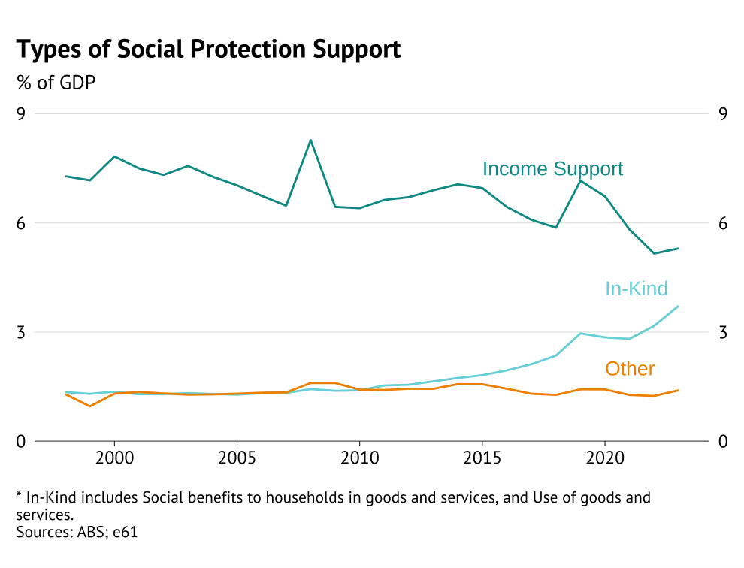

Figure

Unlike income support, which is tightly linked to income, many services are universal or targeted on other criteria. For example, the NDIS allocates support based on disability severity rather than income.

The change in support has two important elements to it which influence fiscal costs – a change in the mechanical driver of cost growth for the payments and a reduction in means testing (greater universalism).

* **Mechanical driver**: Direct payments for services are implicitly indexed by the price of these services – which tends to grow faster than CPI. As a result, the cost of social protection rises more quickly.
* **Limited means testing**: The growing universalism of social support increases the number of participants in social protection schemes increasing the fiscal cost.

The rise of in-kind services explains why social protection payments have not fallen as a share of GDP over the past two decades. Income support has dropped from 7.8% of GDP in 2000-2001 to 5.3% in 2023-24. This has been almost completely offset by a 2.4% increase in in-kind support to households.

The IGR directly acknowledges this fiscal drag: “While the cost of total income support and family assistance payments are projected to grow over the projection period in real per capita terms … the GDP share of these payments is collectively expected to decline. This is because many of these payments are indexed to CPI, which is projected to grow slower than GDP”.

It projects that income support and family assistance payments will continue to grow modestly in real per capita terms but decline as a share of GDP, precisely because CPI grows more slowly than GDP. On official projections, income support is expected to fall by around 0.6 percentage points of GDP in the forty years to FY63 (0.4 from family and other payments, 0.3 from the Age Pension, partially offset by a 0.1 increase in working-age payments) (IGR, 2023).

As with bracket creep in the tax system, governments may choose to “give back” some of these savings, depending on fiscal and social pressures, but the underlying drift provides breathing space elsewhere in the budget.

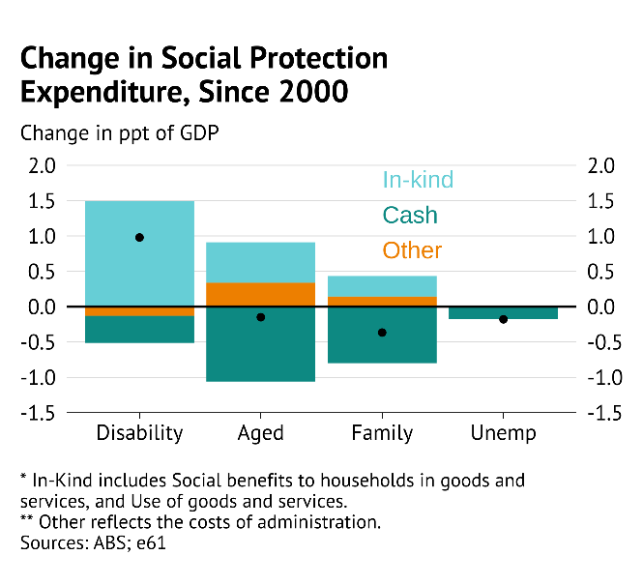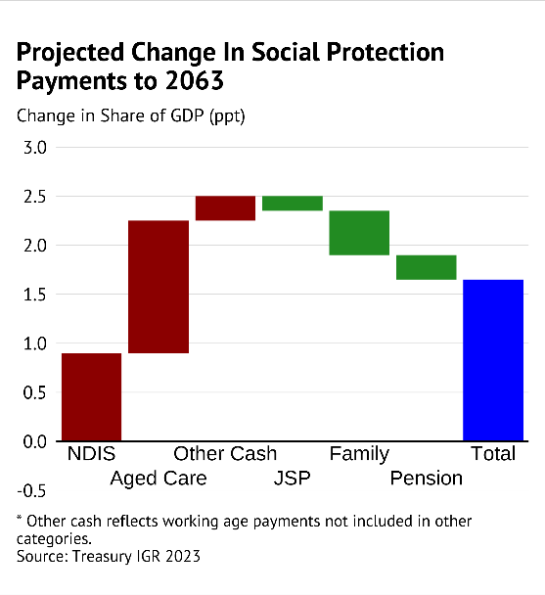

Figure

### A shift in demographic challenges

The shift towards in-kind services will interact with the large demographic challenge of an ageing population over the next few decades. Since 2010, spending on in-kind aged care services has outpaced nominal GDP meaning it has grown from 0.75% to 1.2% of GDP. This trend is expected to continue moving forward, even if the amount spent per recipient remains constant as a share of GDP.

If we assume the probability a person uses aged care only depends on their age, demographic change means that the proportion of people using aged care will rise around 1.7% to 3.1%[29]. The IGR projects a larger **increase in aged care expenditure, from 1.1% of GDP to 2.5% in 2061**. This likely reflects that there will be wage pressures moving forward, as well as other cost pressures[30], which the Treasury also notes could be underestimated in their forecast.

The **NDIS presents a more positive demographic fiscal story**. As the NDIS is a program for those under the age of 65, the ageing of the population will have a minimal impact. If cost relative to GDP was maintained in the NDIS system, demographic forces will actually decrease NDIS spending – all else equal – by around 2% over the coming 40 years. Instead, cost challenges are entirely due to both rising participation within age buckets, and increasing costs per person.

### Economic affairs function

Spending on economic affairs reflects government services and subsidies related to economic activity. By design this is an administrative category focused on providing industry and labour market matching support, which should remain stable as a share of GDP. However, this changed during the COVID pandemic.

Figure

The reason for this initial increase was the unique government supports provided during the COVID pandemic. These were delivered as business- and job-related support – and hence reflected economic affairs spending at both the Federal and State level.

Figure

Prior to the pandemic, the “general economic commercial and labour affairs” (general) category was a relatively small component of Economic Affairs spending. This category captures a variety of labour market supports, such as job search programs, wage subsidies, and related training. With JobKeeper introduced and a series of business supports added to freeze the economy, this general category surged. Other categories, which are made up of functions such as biosecurity and support for tourism were not boosted by COVID. Following three years of elevated spending due to the pandemic, expenditure on economic affairs has now returned to its prior trend and composition.

The nature of the change in spending is reflected in the expense types. Prior to COVID at least four fifths of the spending on economic activity was on employee and capital expenses – with only small transfers associated with drought relief and industry support. However, during the COVID pandemic this shrunk to 7.3% as transfer expenses increased due to programs such as JobKeeper.

Across countries, it is more common to use these types of payments in a countercyclical manner. As a result, such spending tends to vary significantly more in other OECD countries.

Figure

This highlights that such economic affair transfers can be of the nature of general support for households – by supporting job retention or helping job finding. In conjunction with relatively low social protection expenditure, this suggests that overall support for households in Australia is lower during downturns than it is across other countries.

However, if Australia maintains its standard approach to managing unemployment and economic shocks, spending on economic affairs is not projected to rise as a share of GDP over the next forty years.

### Defence function

Government defence spending occurs entirely at the Federal level – with national security a public good that is shared across Australia. Defence spending as a percentage of GDP in FY24 was 1.8% in the consolidated accounts, up from 1.3% in 1999. This is significantly lower than the 2.6-2.8% of GDP ranges that have been quoted (such as by the [Australian Strategic Policy Institute](https://www.aspistrategist.org.au/how-to-count-australian-defence-spending-as-almost-2-8-percent-of-gdp/)), which come from the narrower functional definition of these expenses used in government accounts – specifically the exclusion of pension payments.

Different countries report varying types of labour and capital expenses in their defence statistics – as a result it isn’t clear if this 1.8% could be directly compared to the different international defence targets that are being discussed. The Stockholm International Peace Research Institute harmonises these measures so that they can be clearly compared across countries, focusing on a measure relating to current and capital military expenses – thereby removing donations and veteran pensions. On this basis defence spending in Australia is estimated to be 1.9% of GDP.

Figure

There is considerable pressure from international partners, especially the United States, for Australia to increase defence spending. Given this there is a growing consensus that Australian defence spending will need to rise over the next decade to act as a collaborative player in the current global environment. In Budget 2025/26, the Australian Government did Budget for an increase in defence spending over the next decade to 2.5% of GDP.

Higher spending on defence directly limits fiscal headroom, and must be met by lower spending elsewhere or higher government revenue through taxes. However, there is an added challenge in deciding what should be spent on and how to ensure that the highest value spending decisions are made.

Figure

Growth in defence expenses in recent years has been concentrated in the “non-employee expenses” category. This category has risen from 37% to 50% of total defence expenses – without this increase defence spending would have risen only slightly to 1.4% of GDP by 2024.

This category reflects spending on a wide range of expenses, from ICT upgrading, outsourcing of work through consultants, to payments for suppliers.

The [Defence Portfolio Budget Statement](https://www.defence.gov.au/about/accessing-information/budgets/budget-2024-25) discusses the increase in this spending category and notes the recent requirements for upgrading of ICT infrastructure and rising supplier costs as key drivers.

The cost of procurement, and adequacy of supply chains, are difficult issues in the current national security environment. Furthermore, with defence spending likely to rise – without a clear conception of what value for money in defence looks like – solving these procurement issues and having an adequate framework for thinking about supply chain risk is even more important. Continued scrutiny on spending in this area remains essential.

In the Australian context spending pressures have reflected two key themes:

1. A softer Australian dollar increasing the cost of imported capital equipment and supplies.
2. Cost and time overruns in the investment in new capabilities – which have also forced the defence department to continue to pay maintenance costs on older equipment to maintain capabilities.

The fact that the Australian defence force is facing these capacity constraints at this lower level of spending indicates that a clear strategic plan for spending is necessary for value for money.

## Education function

Consolidated government education spending has remained relatively constant as a share of GDP since 1999 (Figure 42 panel A). Spending was equal to just over 5% of GDP in 1999, rose to 5.5% in 2009 on the back of education related stimulus measures during the GFC, before falling back to 5.1% of GDP in 2024.

But these relatively unremarkable consolidated government spending figures hide a large shift in the responsibility for education funding from state governments to the federal government. Federal spending on education was 33% of consolidated spending prior to 2010 but increased sharply to 45% in 2010 and has remained at a similar share since (Figure 35 panel B).

This large shift in funding responsibilities, combined with the fact that the states still account for over 50% of spending, makes it important to consider consolidated expenditure. A stark example of this is estimates in the [2023 IGR](https://treasury.gov.au/publication/2023-intergenerational-report), which show federal education spending increasing from 1.5% of GDP in 2002-03, to 1.7% in 2022-23. But consolidated government education expenditure actually fell over this period, from 5.2% of GDP in 2002-03, to just under 5% in 2022-23 (Figure 35 panel A).[31]

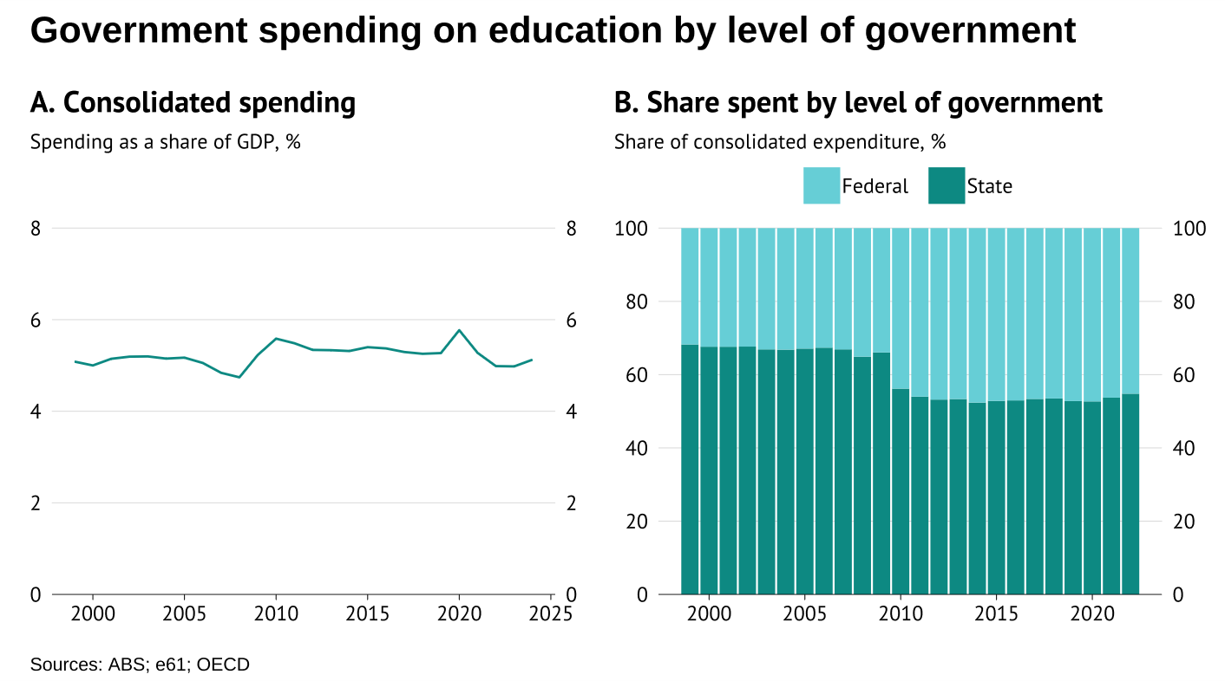

Figure

On its own the increase in federal funding is in many ways unsurprising. It follows large federally funded education related stimulus measures during the Global Financial Crisis, the introduction of the demand driven university system in 2010, and the expansion of federal funding for schools under the Gonski school funding reforms in 2014.[32]

However, the fact that consolidated spending remained relatively flat, while federal spending increased raises the question: why did state government spending fall as a share of GDP? Three trends may help answer this question. The first is a shift from vocational education and training (VET) to university education. The share of students enrolled in largely state government funded VET programs fell from 6% of the population in 2010 to 5% in 2015, while the share of students in federally funded university programs grew from 3.9% of the population in 2010 to 4.4% in 2015 (Figure A.2).

The second trend is the increasing popularity of non-government schools, and growing government funding for these schools. Between 2008 and 2024, the share of school students enrolled in a non-government school increased from 33.8% to 36.3% ([ACARA, 2024](https://www.acara.edu.au/reporting/national-report-on-schooling-in-australia/student-numbers)). At the same time, government funding per student in non-government schools increased from 12.3% of GDP per capita in 2010, to 14.9% in 2023 (Figure A.3 panel B). While funding per student at government schools also increased during this period from XX% to XX%, it did so at less than half the rate (10% in government schools, compared to 21% in non-government schools). The increase in student numbers and public funding for non-government schools has shifted more of the burden of school education onto the federal government as the primary public funder for these schools.[33]

The final trend is the ageing of the population. With the share of the population aged 4 to 25 falling from 31% in 1999 to 27% in 2024 ([ABS, 2024](https://www.abs.gov.au/statistics/people/population/regional-population-age-and-sex/2024)), this has taken some pressure of education spending. The effects of ageing are discussed further in the following section.

### Benchmarking education spending

In this section we benchmark Australia’s education spending in two ways. First, we predict how consolidated spending would have changed if spending per Australian aged 4 to 25 had moved in line with GDP per capita.[34] This demographic benchmarking exercise shows that between 1999 and 2024, education expenditure was higher as a share of GDP than what a combination of population ageing and income growth would predict (Figure 36 panel A). Had spending per Australian aged 4 to 25 grown in line with GDP over the period, education spending would have fallen from 5% to 4.5% of GDP.

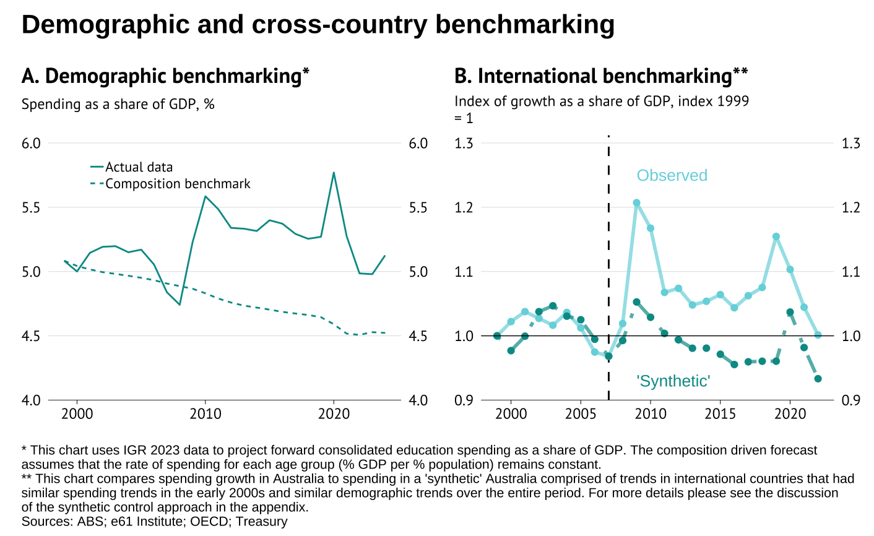

Figure

Of course, over this time the number of young Australians engaged in university education increased significantly, potentially offsetting expected declines in funding due to population ageing. But somewhat surprisingly Australia’s higher than expected level of education spending was not driven by increased spending on tertiary education. Instead, increases in domestic student numbers were almost fully offset by a decline in tertiary education funding per student relative to GDP (Figure A.1, A.4).

Instead, most of the higher than expected education spending growth was driven by school based education. Government funding per school student increased relative to GDP by 10% in government schools and 21% in non-government schools over this period (Figure A.3 panel B). If school funding had instead grown in line with changes in demographics and GDP, government spending would have been almost 0.5 ppt of GDP lower (Figure A.5).

The second benchmarking exercise we conduct uses a synthetic control method to compare actual spending trends in Australia to a ‘synthetic’ Australia constructed from observed trends in other similar countries (Figure 2 panel B). This synthetic control benchmark suggests that since 2009 Australia has seen higher levels of education spending than trends in similar countries would predict. Australia’s consolidated government expenditure increased as a share of GDP by almost 7% in the 2010s, before falling back to 2005 levels after COVID. In comparison, spending in the ‘synthetic’ Australia fell by 4% over the 2010s, and dropped even further post COVID.

Taken together, these two benchmarks suggest that education spending has been incredibly sticky. The ageing of the population and trends in other countries suggest it should have declined by 5-10% as a share of GDP, but it instead increased slightly in the 2010s, before falling back to its previous level after COVID.

This stickiness is a well established feature of the education landscape. The schooling resourcing standard was identified in Grattan (2016) as a key driver of rising cost growth. However, instead the reforms to indexation as part of the 2018 changes (nicknamed Gonski 2.0) focused on how a funding envelop could be used to increase funding for disadvantaged groups and schools – and were arguably not tight enough to restrain cost pressures.

What does this mean for future spending? The 2023 IGR predicts that federal education spending will fall by 0.5 ppt of GDP over the next 40 years due to population ageing ([IGR, 2024](https://treasury.gov.au/publication/2023-intergenerational-report)). Applying the same demographic benchmark as before implies that consolidated spending will fall from 5% of GDP in 2023 to 4.4% in 2063 (Figure 3). But if the experience of the past 25 years is anything to go by then caution should be applied when considering these cost savings as education spending has been very sticky.

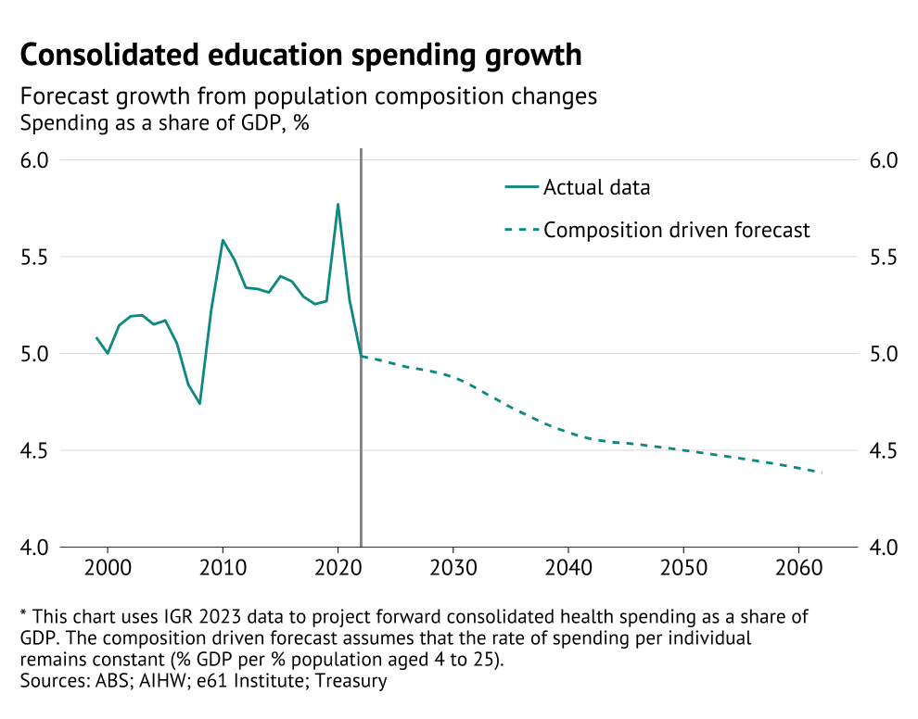

Figure

### Have education outcomes improved?

Education funding may have remained steady as a share of GDP, but this still means that it has increased by almost 50% in real per capita terms since 1999.[35] So has this large increase in real funding led to an improvement in outcomes?

Unfortunately, not. Academic performance has declined across the board. On the OECD’s Programme for International Student Assessment (PISA) test, scores for 15-year-old Australian students have fallen by almost 6% in reading since 2000, 7% in maths since 2003, and almost 4% in science since 2006 (Figure 38 panel A).[36]

Australia is not alone in experiencing a decline in PISA test performance (Figure 4 panel A). However, this decline has been worse than many others. Australia’s PISA ranking fell from 6th in 2006, to 16th in 2018 (Figure 38 panel B). While it has improved back to 7th following the COVID-19 pandemic, this was due to large declines in PISA test performance in other countries, rather than an improvement in Australia’s performance.

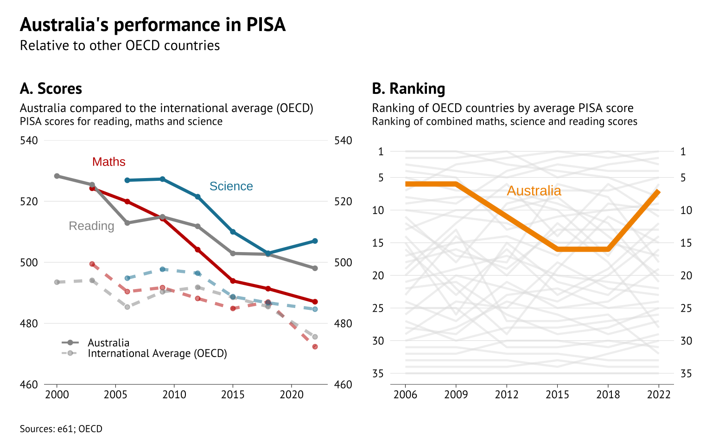

Figure

Does this mean we are not getting value for money from our education spending? Not necessarily. Australia ranks near the lowest among high-income countries for government funding per student relative to GDP per capita – ranking 33rd for school funding per student and 39th for tertiary education funding (Figure A.6).

Australia partly makes up for this with very high levels of private spending, where it ranks 3rd for school education behind only Great Britain and Greece, and 5th for tertiary education, behind only Great Britain, the USA, Japan and Chile (Figure A.6). Overall, this means Australia sits towards the middle of the pack in terms of its level of education funding.

Looking across countries, education funding is also not a particularly strong predictor of education outcomes above a certain level. Above $100,000 USD (PPP, 2021) in cumulative school education funding, there is almost no relationship between education funding and student test performance among high income countries (Figure 5). And many of the high-income countries that outperform Australia on PISA tests, including Japan, Estonia and Canada, spend much less per student.

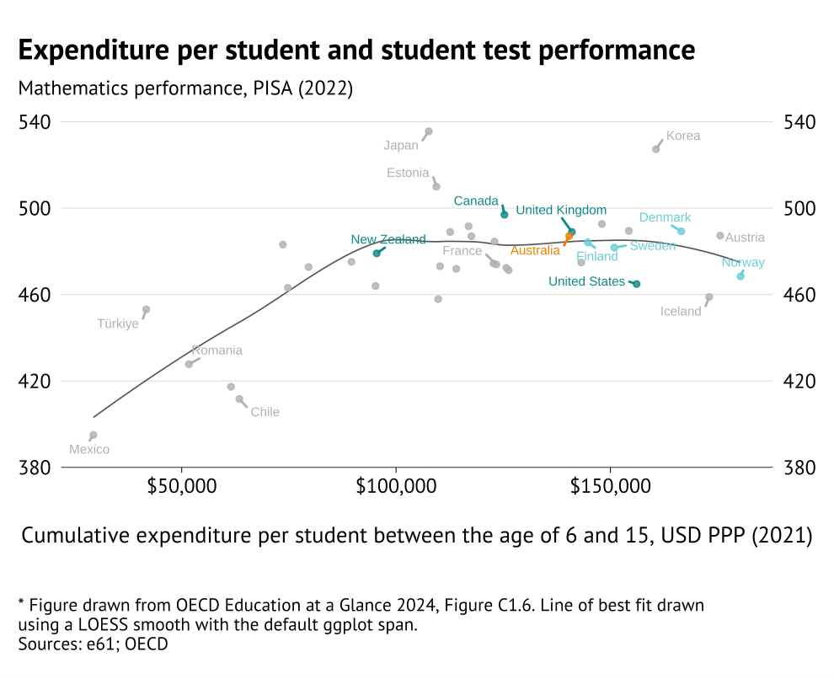

Figure

# Key takeaways about fiscal practices

The spending trends outlined in this report highlight that Australia’s **fiscal system is inconsistent and inflexible**. It is arguably ill-suited to meet the fiscal challenges ahead. Faced with an ageing population, weak productivity growth, and economic shocks, the current fiscal system has tended towards larger and less targeted spending programs. The cost of these programs is higher taxes: either now or for future generations.

Fiscal settings can be distorted or poorly informed if our system of rules and institutions fails to work as well as it could. Australia’s federal and state governments are entering a period in which fiscal trade-offs will be acute. Our system will need to support well informed decisions.

This report has illustrated **six potential issues in current policy setting processes**: Poorly understood baselines, incomplete fiscal rules, short-termism, piecemeal approaches to progressivity, value for money challenges, and the need for greater responsibilities among independent fiscal institutions.

1. **Poorly understood baselines**:

Decisions need to be based on a strong understanding of underlying cost drivers – the demographic and other influences that will shape spending trajectories over the medium term. These baselines help define what is affordable and highlight medium term opportunity costs: individual spending areas cannot all rise by more than GDP growth.

At present, our policy settings show fundamental asymmetries when it comes to natural structural economic drivers. An example of this is **education spending**. Even though the share of the population requiring primary and secondary education has declined, government spending has targeted a fixed share of GDP.

1. **Incomplete fiscal rules**:

Governments are heavily influenced by their primary fiscal targets, even if they are not strictly binding. But political motives drive some arbitrage – perverse policy choices designed to get around the rules. Soft targets reported on by a credible independent fiscal institution would represent a better solution. An example of this is the **focus on the underlying cash balance,** which has led governments to spend money via balance sheet entities to achieve policy aims.

1. **Short-termism**:

A lack of long-term projections means fiscal choices are made on an incomplete baseline. Finite electoral terms and four-year forward estimates can create incentives to focus excessively on the near term. Calls to lower discount rates or invest more in early intervention attempt to address this but can raise their own problems. Tighter fiscal rules regarding balance sheet transactions could help deal with the worst instances of short-termism.

An example of this is the willingness of governments to enter into **arrangements that effectively bring forward future revenue** (such as ‘selling’ a valuable license extension), even when this represents poor value for money in the long term.

1. **Piecemeal approaches to progressivity**:

The **distributional** impacts of tax and spending decisions are important, but they should be assessed holistically. It is inefficient for every program and every tax to try to deliver equity outcomes. A progressive tax system can redistribute even if payments are not means-tested. Targeted transfers can overcome the effect of flat, or even regressive, taxes. Assessing distributional issues at the level of individual policy means thereis a tendency to only allow for a policy if there are no losers. However, this rules out policy packages that could support everyone – simply as individual components of the package may have losers.

1. **Value for money challenges:**

The weight of government spending has shifted from income transfers to in-kind services. Within those services, an increasing share is delivered via payments to third party providers. It is getting harder to judge, and harder to influence, the value for money delivered to service users and taxpayers. Market design in areas such as disability, employment services, child care and aged care have proven challenging. A greater policy focus on outcomes is needed, as well as greater realism about the potential impact of new and expanded programs. An example of this is that, in aggregate, increased spending in health and education does not appear to have delivered commensurate improvements in outcomes.

1. **The need for independent fiscal institutions:**

Australia’s government sector is not just the Commonwealth, with states also having increased influence over fiscal aggregates. While spending decisions are still best left with elected governments, independent fiscal bodies like Parliamentary Budget Offices (PBOs) can help inform decisions and debate. Irrespective of rules and settings, contestability of projections and ideas – from both independent fiscal institutions like the PBO and private actors – can improve policy settings.

An example of this is the **extended scope of the Office of Budget Responsibility (OBR) in the United Kingdom**. The OBR has additional responsibilities, which includes independent forecasting and assessing the performance of government against fiscal targets and benchmarks.

Together, these six issues highlight possible directions for future reform. However, they are not a checklist. Many aspects of Australia’s existing fiscal institutions have arisen as responses to observed problems. Short-term planning, high discount rates, limited fiscal rules, and universal transfers were all pragmatic solutions to difficult policy trade-offs specific to the circumstances of the time. This suggests a need for caution in reforming individual aspects of the system without understanding the role they play. Some piecemeal reform could lead to worse decisions being made, rather than better ones.

In a **forthcoming companion report,** we highlight specific case studies of Australian policy decisions and describe the practical choices behind each of these fiscal issues in greater detail.

# Bibliography

[Insert on transition into final document]

1. Historic general government gross debt was sourced from the Historic Public Debt Database maintained by the IMF (IMF, 2010).
2. Note that the Australian financial year in June based, while other countries in this sample are based on the calendar year.
3. Note that the level of spending the base OECD consolidation and the “Spent by” consolidation do not match – a limitation noted in Dougherty and Montes (2023). Using the spent by category to discuss relative Federal and State trends suggests that Federal spending growth has been much more important. This is potentially a result of a shift towards “tied” funding instead of “untied” funding for States. However, the OECD notes there are potential measurement issues for the UK and Australia, and so we only focus on this measure for evaluating specific spending functions.
4. There is significant debate about how Australian GST revenue should be classified (e.g. OECD, 2013). By its nature the revenue is passed on without condition to state governments. However, states have no autonomy about how the tax is levied and at what rate and base. Complicating matters, similar arrangements in Germany are attributed to the state and local government level. In the OECD figures GST is counted as a federal tax, but is then transferred to be state revenue in the revenue statistics.
5. With lower spending to GDP in Ireland, Switzerland, Lithuania, and Israel.
6. The 7 lowest, with only Mexico, Ireland, Chile, Switzerland, United States, and Lithuania lower.
7. This has been highlighted in surveys of tax autonomy undertaken by the OECD (OECD, 2025).
8. Footnote on PCA analysis, and link to the write-up of it in the appendix.
9. The ABS measure is our preferred measure for the stance of general government spending and revenue – given the consistent treatment of the Government Finance Statistics, and the availability of the FY24 data. However, we do not have access to granular ABS function expenditure data by level of government. As a result, we use the OECD to fill in the gap about federal relative to state/local attribution of spending on functions.
10. Add productivity and ageing literature here – Italian paper on job ladders for a negative story, UK cross-country study on unclear relationship.
11. Compares the seasonally adjust quarter in December 2019 to June 2025. Annualised per capita growth in incomes was still weak over this period, at 0.58%pa for GDP and 0.99%pa for RNNDI. RNNDI is also supported by the improvement in Australia’s net capital position, leading to an improvement in net foreign capital income.
12. For these projections the method includes government investment and income transfers, as the focus is on the overall outcome for government expenditure.
13. These can be found in Statement 8 (Statement of Risks) in Budget Papers 1.
14. These can be found in Statement 7 (Forecasting Performance and Sensitivity Analysis) in Budget Papers 1.
15. The full discussion of economic activity and defence spending are provided in Appendix XX.
16. Real expenditure in 2024 dollars is calculated using the Consumer Price Index.
17. Consolidated government expenditure as a whole grew by 1.3% of GDP over this period, from 34% of GDP in 1999 to 35.3% in 2024. Even focusing just on areas that have grown as share of GDP, health still accounts for almost half of all growth in government expenditure. The next fastest growing category, social protection, grew by less than 0.7% of GDP, despite starting from a much higher base. Note that the absolute increase in social protection was larger than the increase in health spending.
18. For instance, under the National Health Reform Agreement, the Commonwealth pays around 40–45% of the “efficient price” of public hospital services, through Activity Based Funding (ABF).
19. If spending in these areas had grown at the average rate of health care expenditure growth, then spending would have increased by 1% of GDP, rather than 1.57%.
20. If labour expenses had grown at the rate of average health expenditure growth they would have risen by 0.13% of GDP less, or roughly 8% of the increase in health care expenditure between 1999 and 2024.
21. Based on AIHW disease burden database estimates from 2016 to 2022.
22. We focus on the period from 2005 onwards as this is the period for which we have detailed health expenditure data from the AIHW disease burden database.
23. This approach compares trends in Australia to a 'synthetic' Australia constructed based on trends in countries that had similar health care spending trends in the early 2000s and similar demographic trends over the period. Appendix X provides more details on the synthetic control method.
24. The IGR’s detailed forecasts expect that federal government health spending will increase from 4.2 % of GDP in 2023 to 6.2% in 2063 (IGR, 2023). If state expenditure rises at least in line with federal spending, as it has done over the last 25 years, then the IGR forecasts imply that consolidated government health spending will rise from 7.1% of GDP in 2024 to roughly 10.5% of GDP in 2063 (IGR, 2023).
25. Similar work by the Productivity Commission using World Bank data found that healthy life expectancy at birth increased by 1.5 years from 71 in 2003-04, to 72.5 in 2018-19 ([PC, 2024](https://www.pc.gov.au/research/completed/measuring-healthcare-productivity)).
26. In 2021, the lowest HALE recorded among countries in the WHO database was 44.63 years for Lesotho. Similarly, research by the PC in Australia estimated that the expected value of HALE was 44.2 years, after controlling for health care spending, age and various positive and negative risk factors ([PC, 2024](https://www.pc.gov.au/research/completed/measuring-healthcare-productivity)).
27. Benchmarking based upon need (i.e. spending per disabled person) appears natural. However, it is complicated by the fact that reported disability prevalence increases with program generosity and support availability. Some portion of the increase in reported disability in Australia likely reflects the existence of the NDIS – making cross-country comparisons difficult.
28. This includes, for instance, homelessness assistance; prisoners aid, care for refugees, Aboriginal and Torres Stait Islander welfare services; benefits in-kind to those in times of family and personal emergencies.
29. This is assuming the probability of use within a given age range stays the same, but we all the population to age in line with projections over the coming decades.
30. While aged care expenditure per person has roughly kept pace with nominal GDP growth over the past 20 years, and has grown below it from 2019 to 2024, it grew faster than nominal GDP over the 2010s. It’s possible that if nominal GDP growth slows, due to productivity, that aged care expenditure per person could also grow faster.
31. Note that the implied federal share of spending from these figures may not align with those in the figure below as they are drawn from different sources, which use different methods to assign expenditure.
32. During the GFC the federal government spent over $16 bn on education related infrastructure stimulus measures under Building the Education Revolution package.
33. The federal government is responsible for 80% of recurrent public funding for independent school, but only 25% for government schools ([Department of Education, 2025](https://www.education.gov.au/schooling/how-schools-are-funded)).
34. For simplicity we use the share of Australia residents aged 4 to 25 years old for this measure of school and university aged Australians.
35. Between 1999 and 2024, government spending on education grew by over 50% per capita, rising from roughly $3,500 per person to over $5,000 (Figure 1 panel A)
36. Data on maths and science performance is not available from before 2003 and 2006 when both were first included as major domains for the first time.